Product Information Management System for E-Commerce

Team - 05
Team Members : Vashu Sharma , Mansi Garg , Subhadeep Ghosal

Create a web portal to manage product data for E-commerce website fro managing Footwears

- Portal Login/Registration:
  - Registered user should login using email address and password.
  - New user can be registered using email address and password.

Solution(1) : First a simple registration page will be created which will store the information of the user registering ,A notification will be sent to user who is registering and also a login page will be created for user to login.
Reset-Password : Their will be an option for reseting the password in case the user forgets his password.

- User and Role Management: Admin user can manage the user’s info, create new role and assign role to user.

Solution(2) : Role Admin – Admin has all the privileges ,Admin can add new user and can assign different roles to them , Admin will also be responsible for adding,editing,deleting the categories.

Role Manager – Manager will be responsible to add, edit, delete data(product information) in the different categories created by Admin.

Role User – User will be the normal users registering and they will be allowed to see the list of products with the attributes like price, colour etc.

- Product Data Modeling – Identify the product attributes, categories and design database. Each product should assign to specific roles.

Solution(3) : A database will be created which will consist of different entities like User(it will store users information), Footwear Category entity(it will store the information related to category of footwear), and then the last table will be the product table which will consist of the product information and will consist of various attributes .

Database details are given below :
Table 1. User Table : It will consist of the user information which user will enter while registering

Table 2. Category Table: It will consist of the information about each type of the footwear and its description

Table 3. Product Table: It will consist of the information about the products in the form of the attributes as shown below ():

1.Footwear Type (casual,formal etc)
2.Color (red, blue etc)
3.Brand (brand name)
4.Material (material name)
5.Size (shoe size- 6,7 etc)
6.Section (Men,women,kids etc)
7.Product Image (image of product)
8.Durability (low medium high)
9.Ease to wear (comfortablity– easy ,medium etc)
10.Product Short description (overview )
11.Product detailed description (detailed info)
12.Quantity in stock
13.Market Price
14.Discount
15.Selling price (price after discount)
16.Occasion (party wear, casual etc)
17.Sole Type (kind of sole)
18.lace type (lace-less, with lace etc)
19.weight (weight in grams)
20.Rating (1 star , 2 star, etc)
21. Attribute-1 (we can add further attributes)

SCREENSHOT OF DATABASE
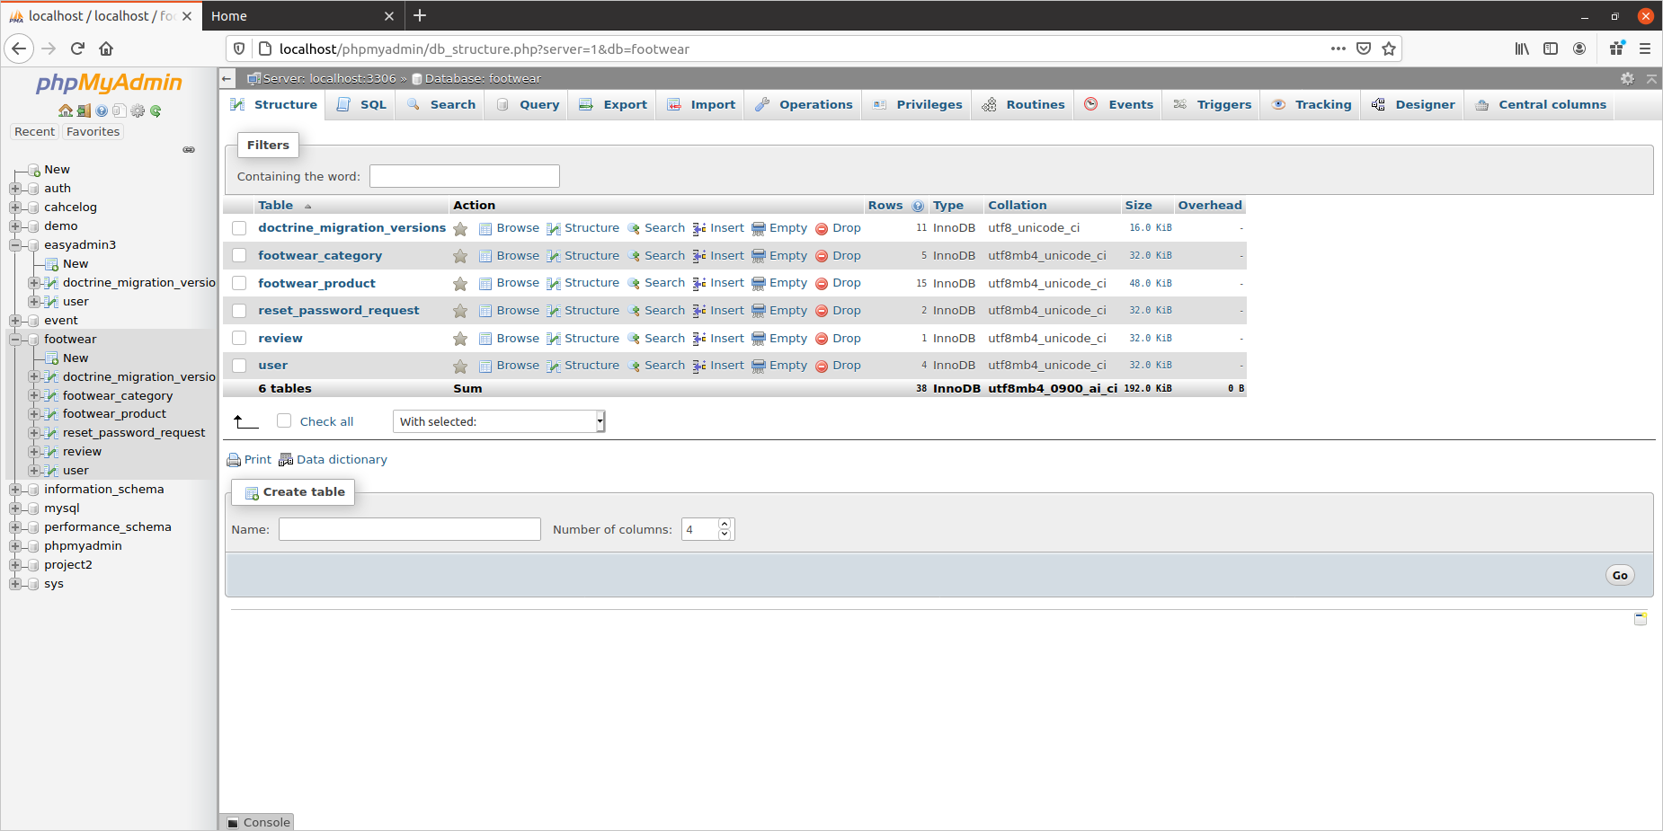
>We have created a database name footwear and it consist of these tables named as footwear_category, footwear_product, reset_password_request, user, review.

STRUCTURE OF USER TABLE

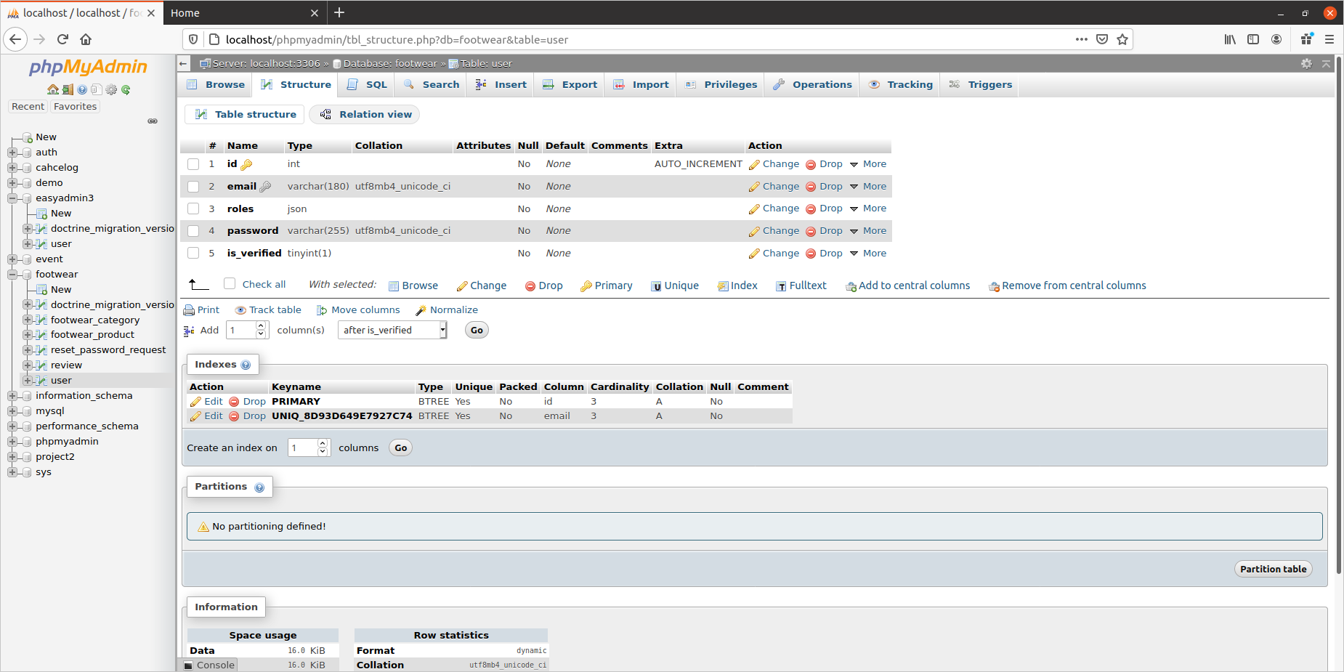
>In this user table we have user’s email password ,is_verified field,roles and email

1. email: stores the email id entered by the user during registration.

2. roles: when user will register then its default role will be the [“ROLE_USER”] but admin user [“ROLE_ADMIN”] who is pre-persisted has the privileges to change the roles of any user for example in this project we have taken three roles as ([“ROLE_ADMIN”], [ROLE_MANAGER], [ROLE_USER]). , and if the admin wants a particular user to act as a manager then admin can edit his role from ROLE_USER to ROLE_MANAGER. Then that user who has now been assigned the role of the manager will have the privileges of the [“ROLE_MANAGER”] .

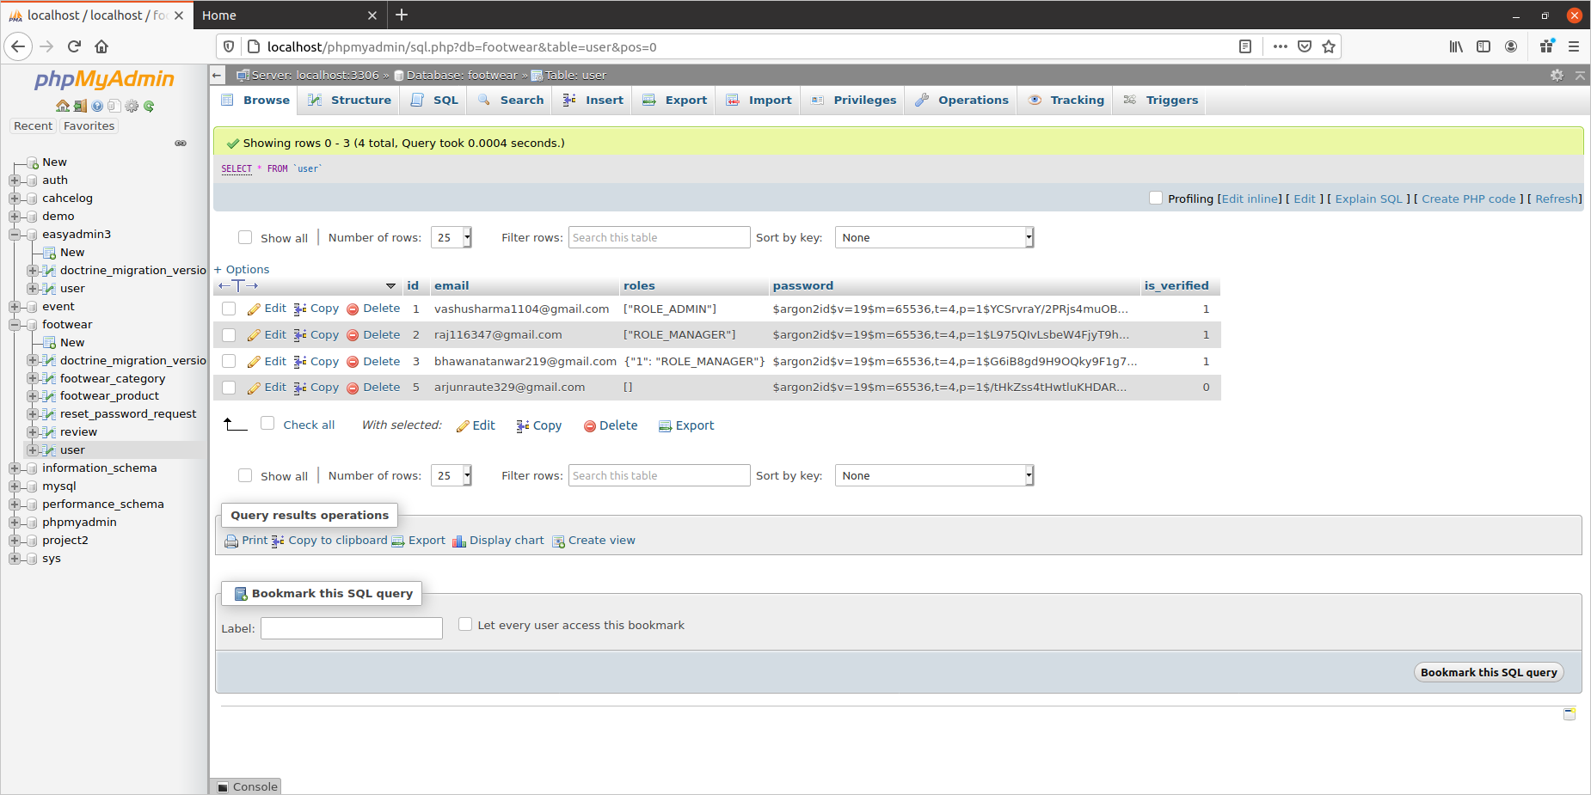

3. password: stores the password entered by the user during the registration in the encrypted form.

4. is_verified: this column was added when we created the registration form using the command { “bin/console make:registration-form” },which tells user is verified or not

STRUCTURE OF CATEGORY TABLE

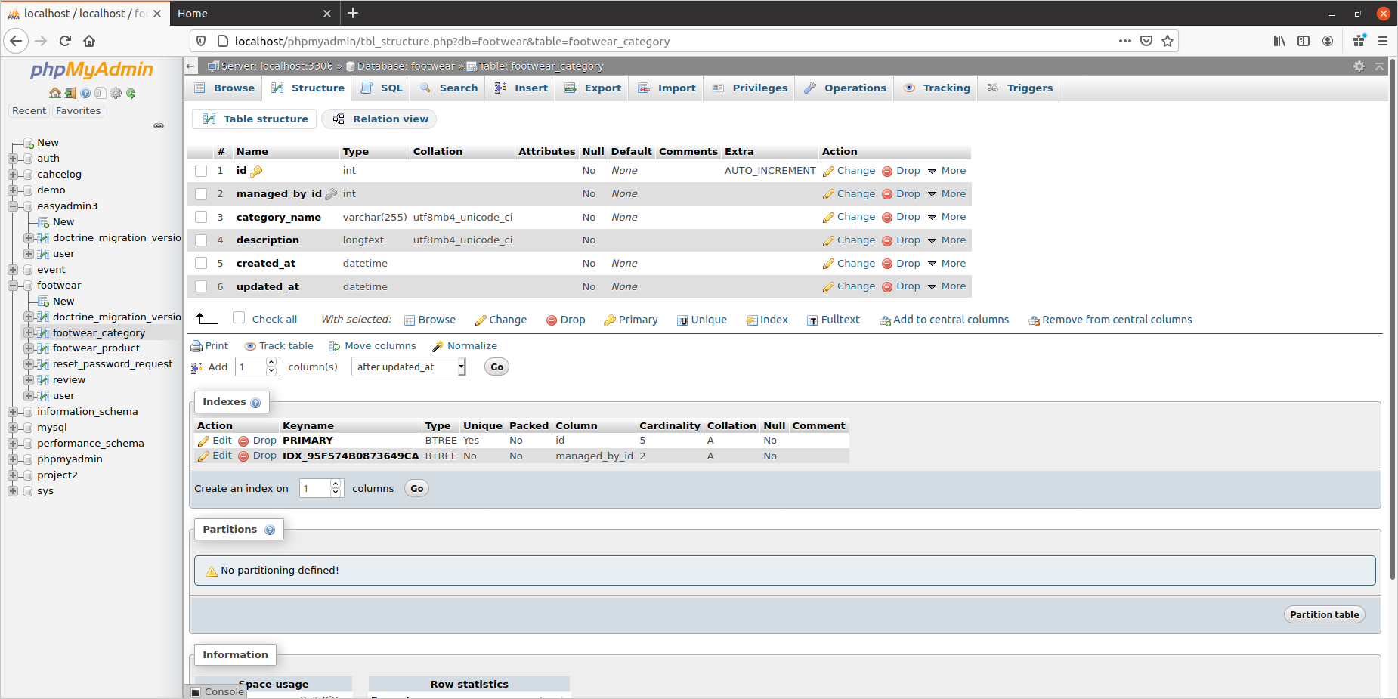

This is the Category table : This table contains the category of the products so according to our design each product will fall under some category like for example we have the domain of the footwear so we have some categories in footwear as Shoes, sandals ,Slippers, etc and now the products in the product table will be having category id as the foreign key which well tell us which product falls under which category .

DETAILED EXPLANATION :

1. managed_by_id : this is the foreign key which is connecting the user table with the category table so this category is managed by some user whoes role will be [“ROLE_MANAGER”], The idea behind that was that now we are assigning the entire category to the manager and whenever a new category is added by the admin then the managers will also receive a mail that a new category has been added and assigned to the manager.

2.category_name : category name is the name of the category like in our case in the domain of the footwear the category names can be like Shoes, Sandals, Slippers, Heels , Flats etc.

3.description: description is just a small description about the category.

4.created_at/updated_at : it just stores the date and time that when categories were added and in updated stores the info when it was updated.

PRODUCT TABLE

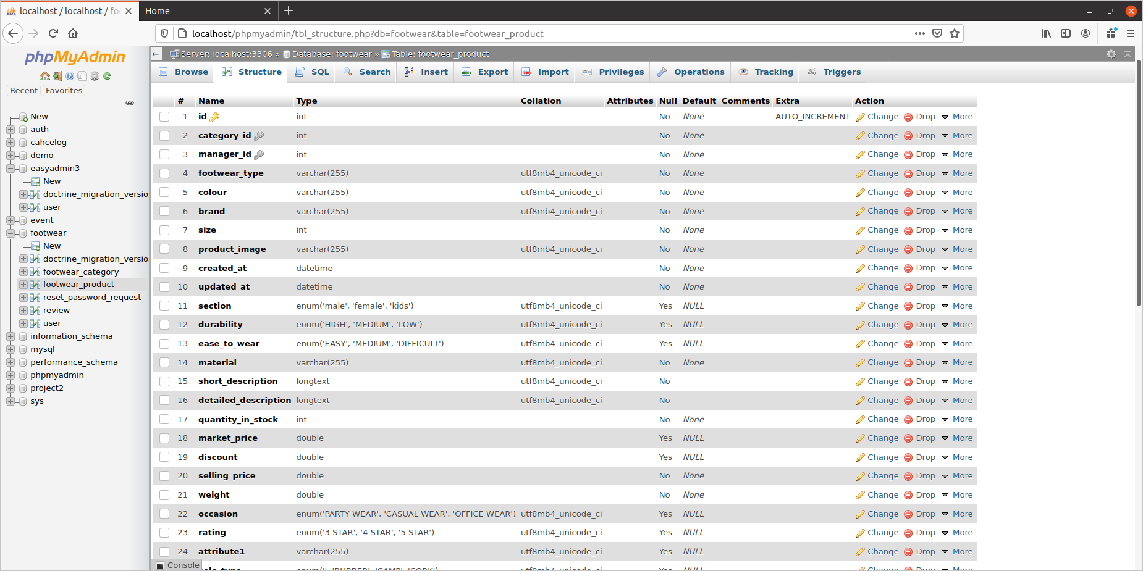

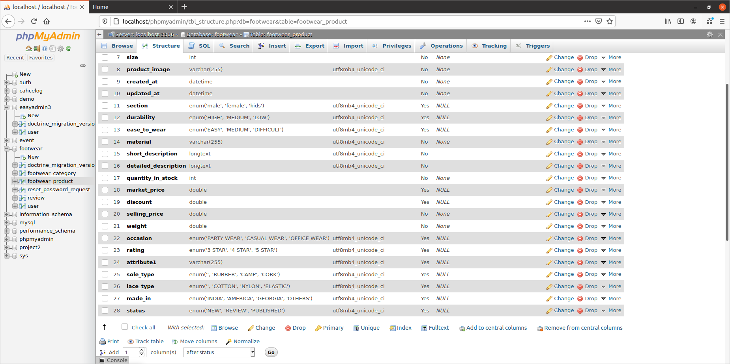

This is the structure of the product table in this table we have one auto generated primary key and to foreign keys , first one is the category_id which will help in making a connection between the category table and the product table so that each product can fall under some category and second key is the manager_id which is connecting this product table with the user table so that we can see which product has been imported or added by which manager .

DETAILED EXPLANATION:

1.category_id : this is a foreign key which makes a connection between the category table and the product table each product in the product table will fall under a category then we can assign the whole category to a manager or some other role.
Example: category table has a category as Shoes and now product table has a product as formal shoes so now for better understanding the formal shoes product will fall under the category of the Shoes with the help of this category_id foreign key.

2.manager_id : this foreign key develops a relationship with the user table so that when a manager imports the data in the products table then admin can get that which manager has imported the data if there are multiple managers.
Example: A manager has imported the products and something goes wrong so the admin can check that which manager has imported the data.

3. then after that we have multiple attributes for products.
Reset-password table

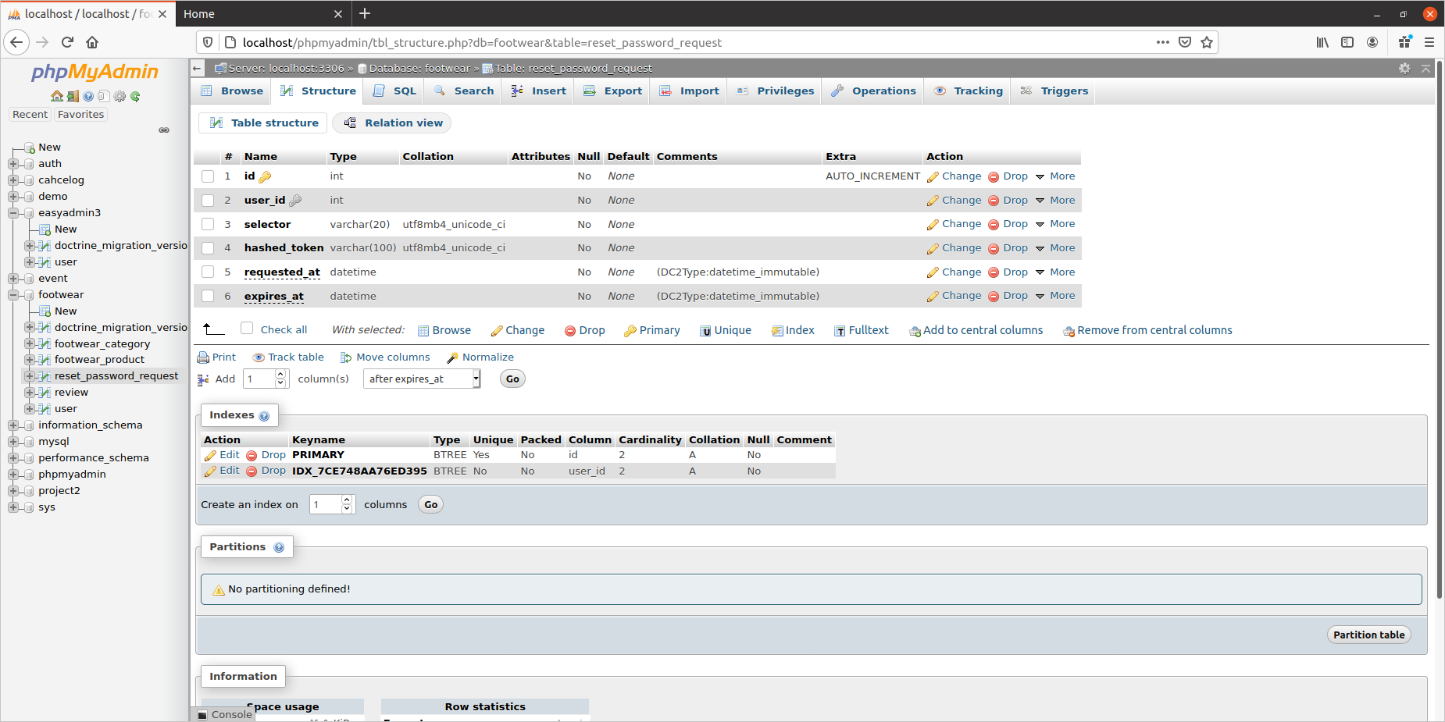
This is the reset-password table which was created when we installed the bundle “composer require symfonycasts/reset-password-bundle” to reset the password of the user in case he forgets his password.

It stores user_id as foreign key to make a connection with the user table

- Product Create/Edit page: Design a page to display product detail and edit page.

Solution(4) : A dashboard will be created for Admin who has the privileges to see, edit, delete everything and similarly dashboard page for the managers so that they can edit, delete the products in the categories assigned to them, where as the normal user will only be allowed to see the list of products along with the attributes.

- Product Listing Page:
  - Design a page to list the products. Product listing should be restricted based on the roles.
  - User can delete one or multiple products from list page.
  - Admin user should see all the products and assign one or multiple products to user.

Solution(5) :

(a) – Product listing will be based on the roles assign to the different users like Admin can do everything like adding,editing,deleting the products etc and managers will be allowed to add, edit, delete, see the list of products assigned to them.

(b) – Manager can edit, delete, add multiple products from the categories assigned to him.

(c) - Admin can assign products to the managers for their respective categories , and admin can see all the products and categories.

- Bulk Import:
  - Backend system (Symfony Command) to import products and categories in bulk by reading the JSON
  - Create product and category JSON files.
  - Aggregated import result should be logged in logger system, Monolog can be used.

Solution(6): For importing large amount of data in our database we will creating JSON files for that such as product and category JSON files will be created and category JSON file will be imported by admin only and product JSON file will be imported either by manager or by admin.

- Workflow: Symfony workflow to manage product states like new/draft, review, published.

Solution(7) : Their will be a status for the product and that will change as, when a new product is added to then its status is new/draft , when that product is assigned to a manager for reviewing then the status of the product changes to review and when that product is approved by the manager then its status changes to published

- Email Notification: User should be notified when product is assigned.

Solution(8) : An email notification will be sent to the manager when a new product/category is assigned to him by the Admin.

- Outbound API: Webservice API to expose product data to website.

(DOUBT REGARDING THIS)

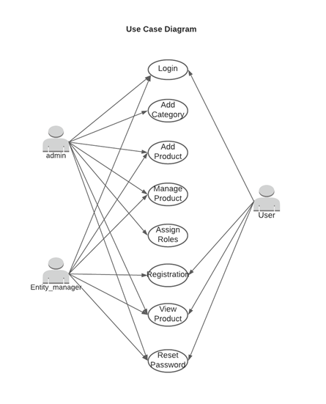
USE CASE DIAGRAM

USE CASE

-> The first page of our website will be the login page where the already registered user will enter the credentials and will get logged into the website and will see the pages and perform actions according his/her roles.(the privilages of the roles is explained in detail below)

-> On the login page their will be a link to the registration page where the new user can register through his email id and password, users can also resest their password in case they forget their password.

-> Their will be an Admin dashboard for the admin to manage and keep a check on all the things such as users information, product entity, categories etc , and an Admin dashboard page for the Manager but some actions will be restricted to only admin. And manager can perform the actions assigned to him for example adding products to the product table using that dashboard page.

-> For User which will be our default entry through the registration he will only be allowed to see the list of the products which are in the available state

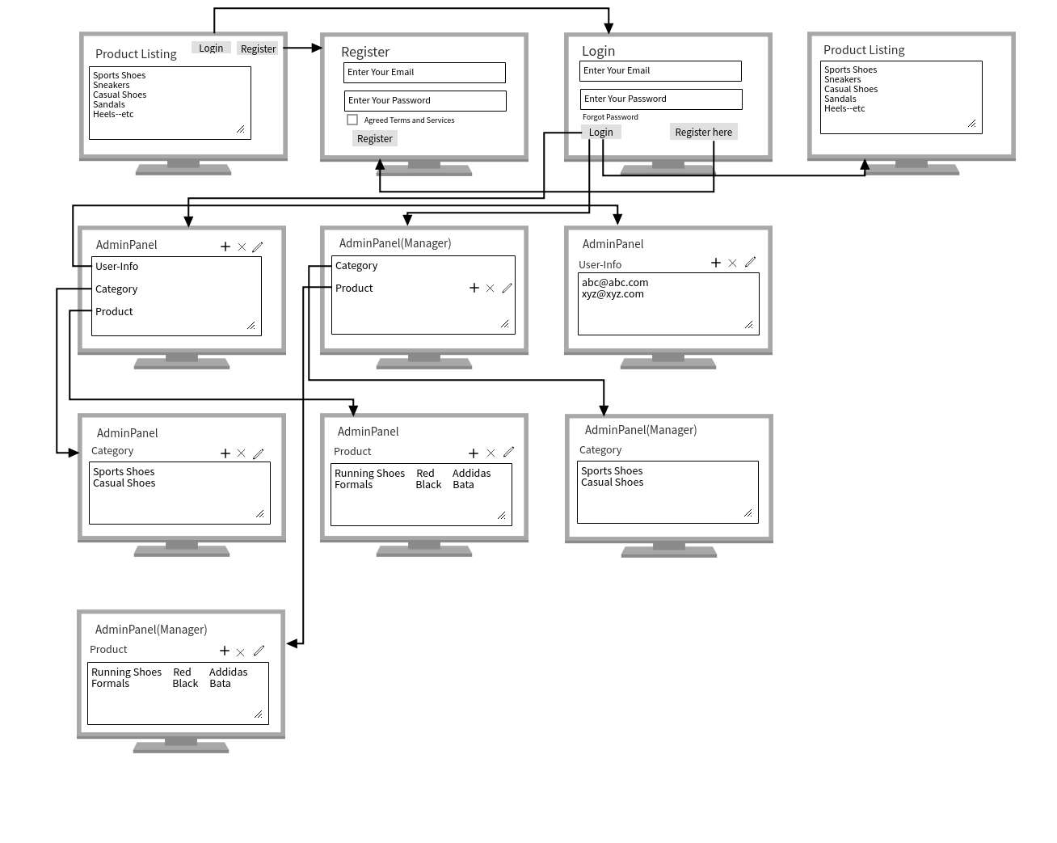
WIRE FRAME

USER ROLES

(1.) Admin :

First let us consider an Admin User, so admin will have all the privilages to add, delete, edit the categories in the footwear category entity as well as the products in the footwear product entity , and only Admin will be able see the users information table and he can also delete a user and change their roles according to the requirement .

(2.) Manager :

Manager role will be assigned by the admin when the user has been registered then the privileges of manager role is that he will be able to see the categories but he cannot add,edit,delete them. The manager user will be responsible to manage the products such as adding,deleting,editing the products in the footwear products table.

(3.) User :After registration the default entry of the role will be the user role and the privileges of the normal user is he/she will only be allowed to see the list of the products which are in the active/available state.

WORK DONE TILL NOW

DATE: 20-01-2021

1. Registration form is created and on registration an email has been sent to the user on the email id provided by him.

2. Login form is created using which the user is logging in to the website.

3. Reset-Password is done.

4. Database design has been done.

5. Admin pannel has been created.

6. Role Privilages have been decided.

7. Data CRUD is working(dummy data ).

DATE: 21-01-2021

8. Bulk data importing has been done :
We have completed the bulk data importation with the help of JSON file . So now we dont have to enter the data one by one we just have to create a JSON file for the products and then just use the import button to import bulk data into our databse.

9. We have also designed a User Interference more of a page on which the normal user can see the list of products where as when the Admin user is logged in then there will be an option for him to go to the admin dashboard and similarly there will be an option for manager to go to the manager dashboard. We have also applied every security like even if the normal user manages to break into the admin pannel then also he will not be able to see the information present in the admin dashboard.

10. And at last we also added some more attributes to our product table as suggested by sir.

DATE: 22-01-2021

11. Bulk data export has been done

12.Status of the products have been managed only published products have been shown to the user.

13. An Email event has been attached on the creation of a new category the manager to whom the category is assigned tto will get an email notification.

DATE: 23-01-2021

14. Managed the export functionality that only published product would get shown to user and would get exported.

15. Worked on the user interface and styling of pages.

22-01-2021
FLOW OF THE WEBSITE

DEFAULT PAGE

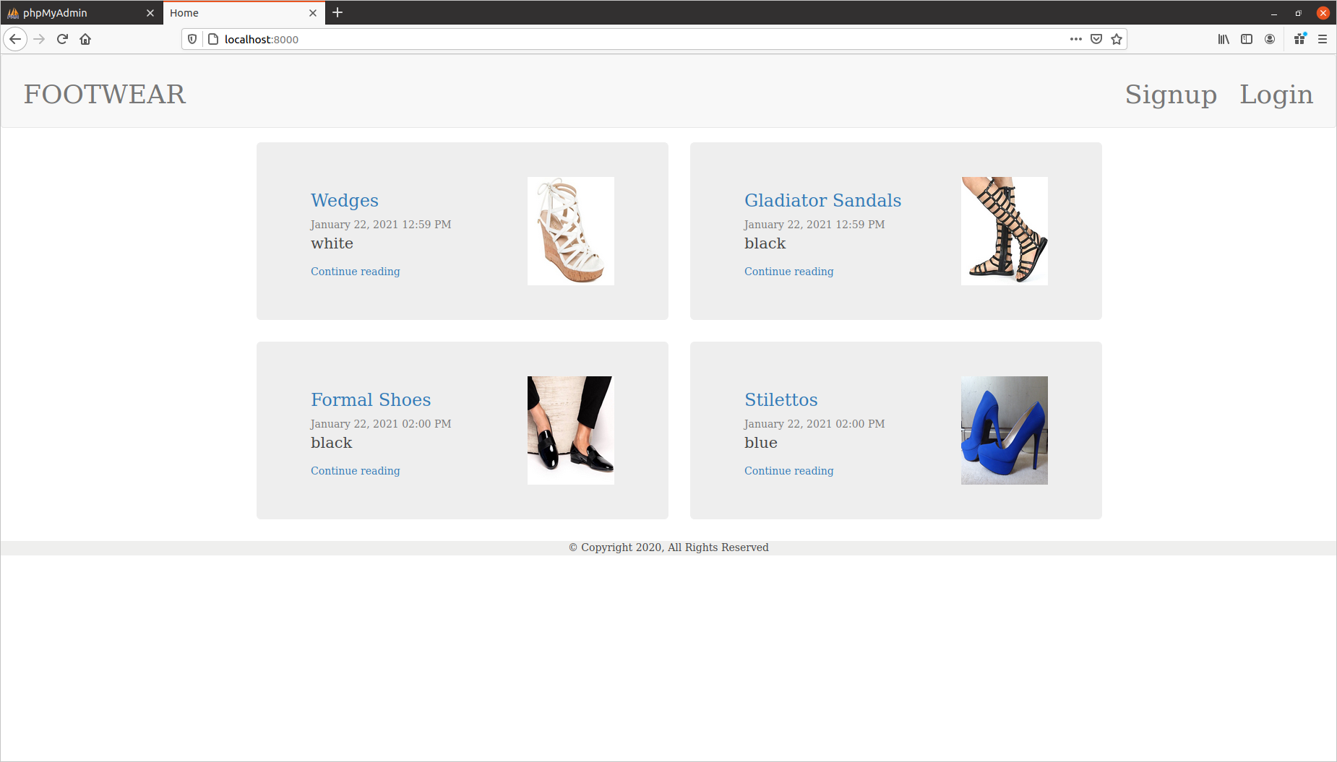

This is the default page of our website. User can see the product and the details of product and he also has the option to log in ,
Our thought process for showing the products without login was that in many shopping websites we saw that we can see the products even if we are not logged in but to further do some action like ordering or commenting then the user has to login for that.

There are two options for the user if he as already registered then he has the option to login and if he is a new user then he can register himself so first we will take an example of new user .

New User signing up or registering to the website

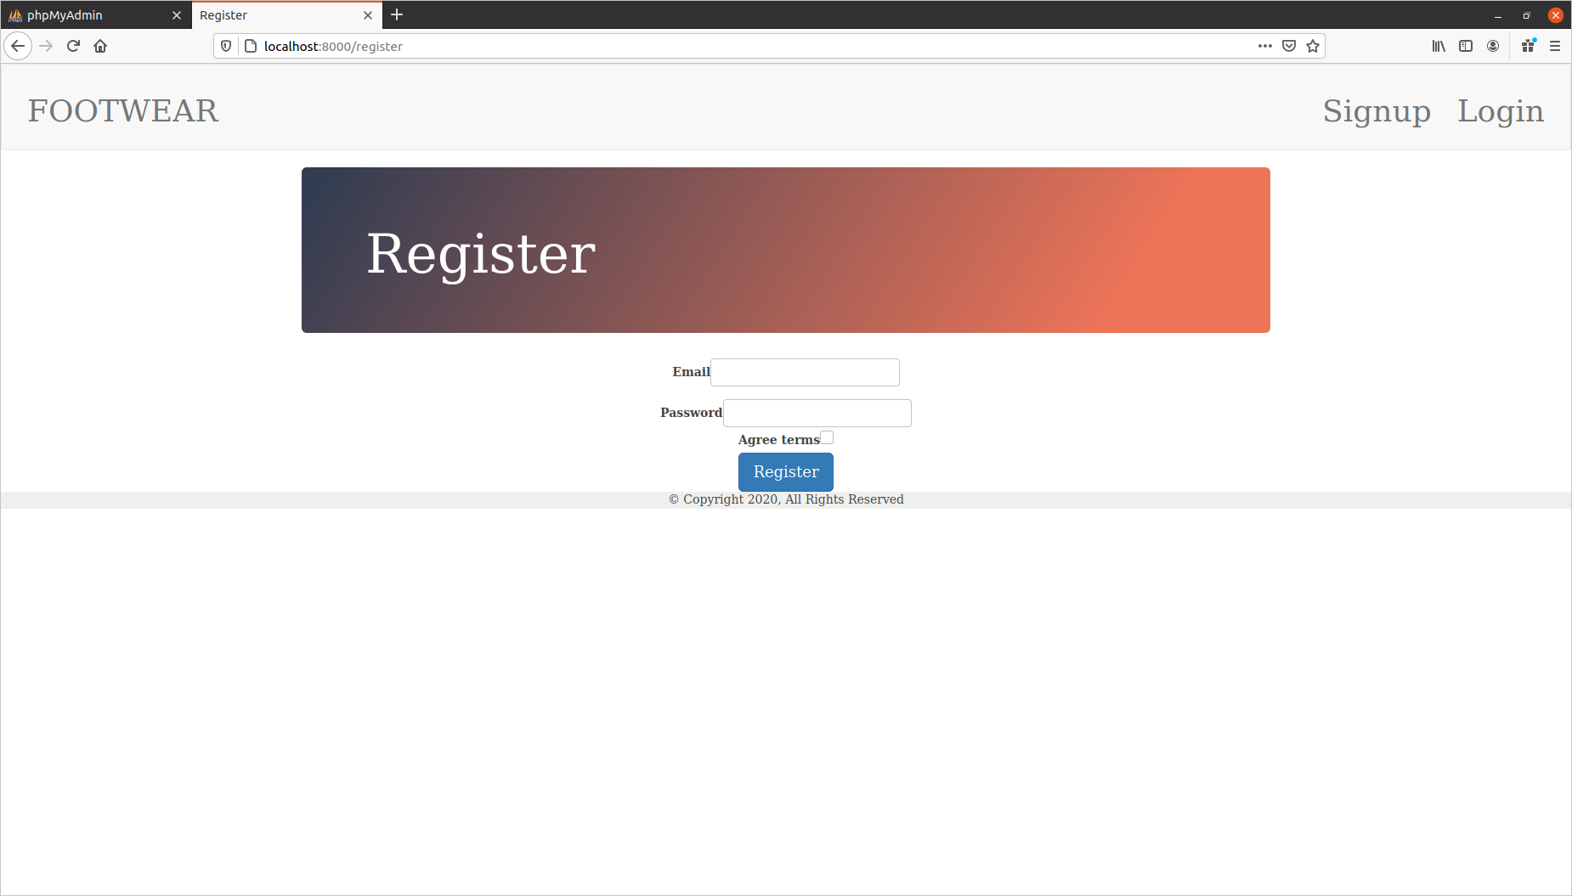

This is our registeration page where the new user can register himself as a normal user by entering his email id and password and also we have attached a function that an email will also be sent to the user that he has been registered to the website.

After this the user will land to the login page

LOGIN PAGE

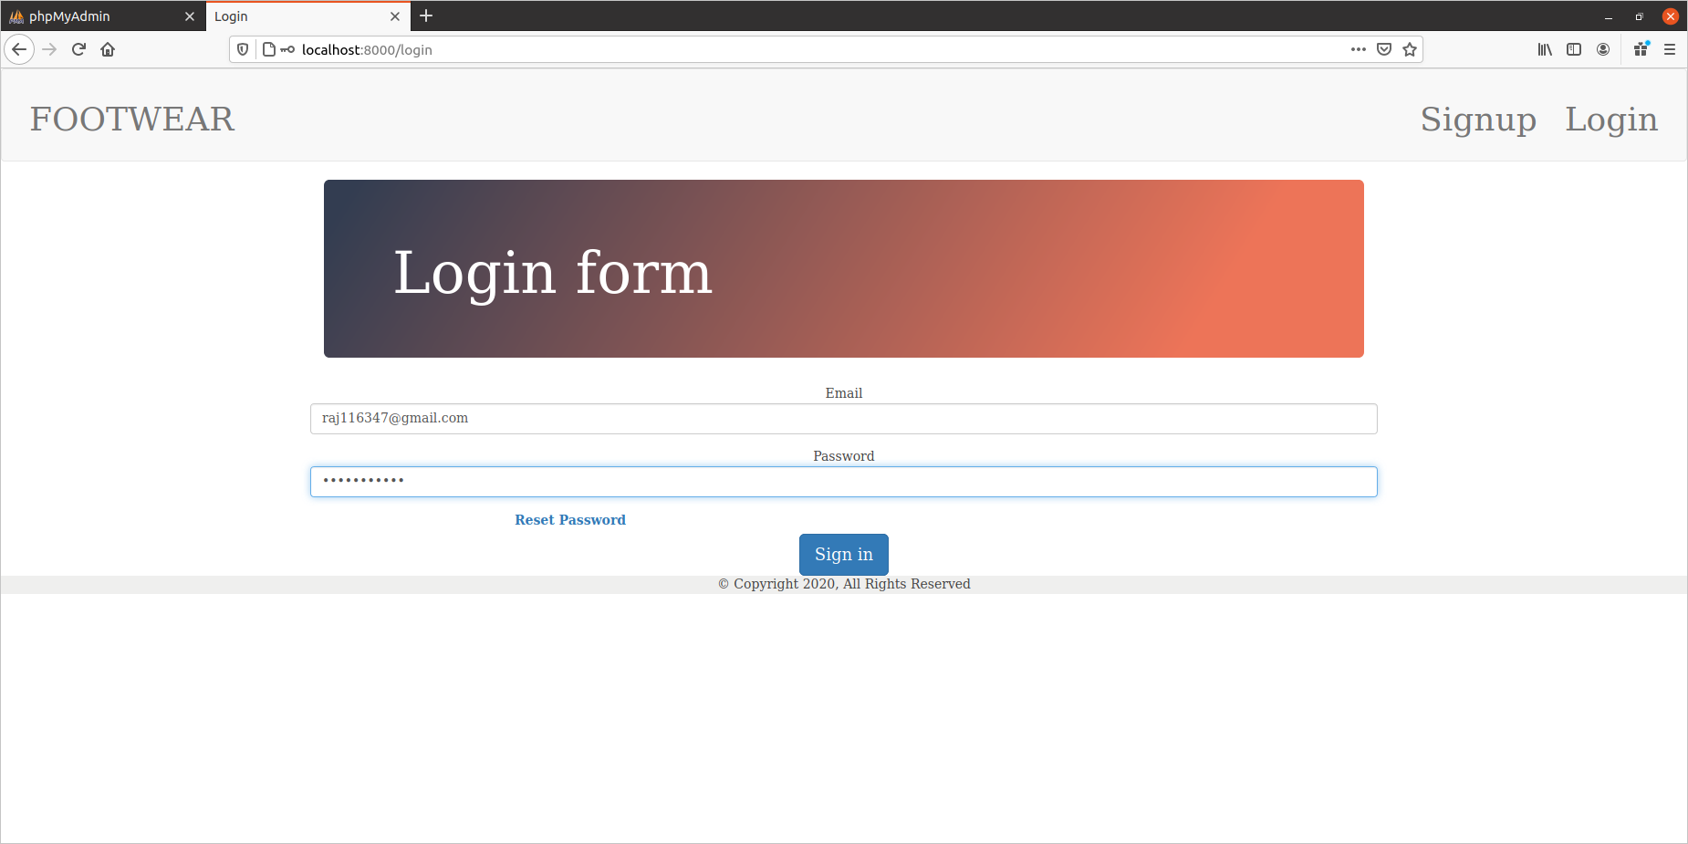
This is our login form from this page user can log in to the website. There is also an option for the reset-pasword so in case user forgets his password then an email for reset password will be sent to him.

After clicking on the reset password

RESET PASSWORD PAGE

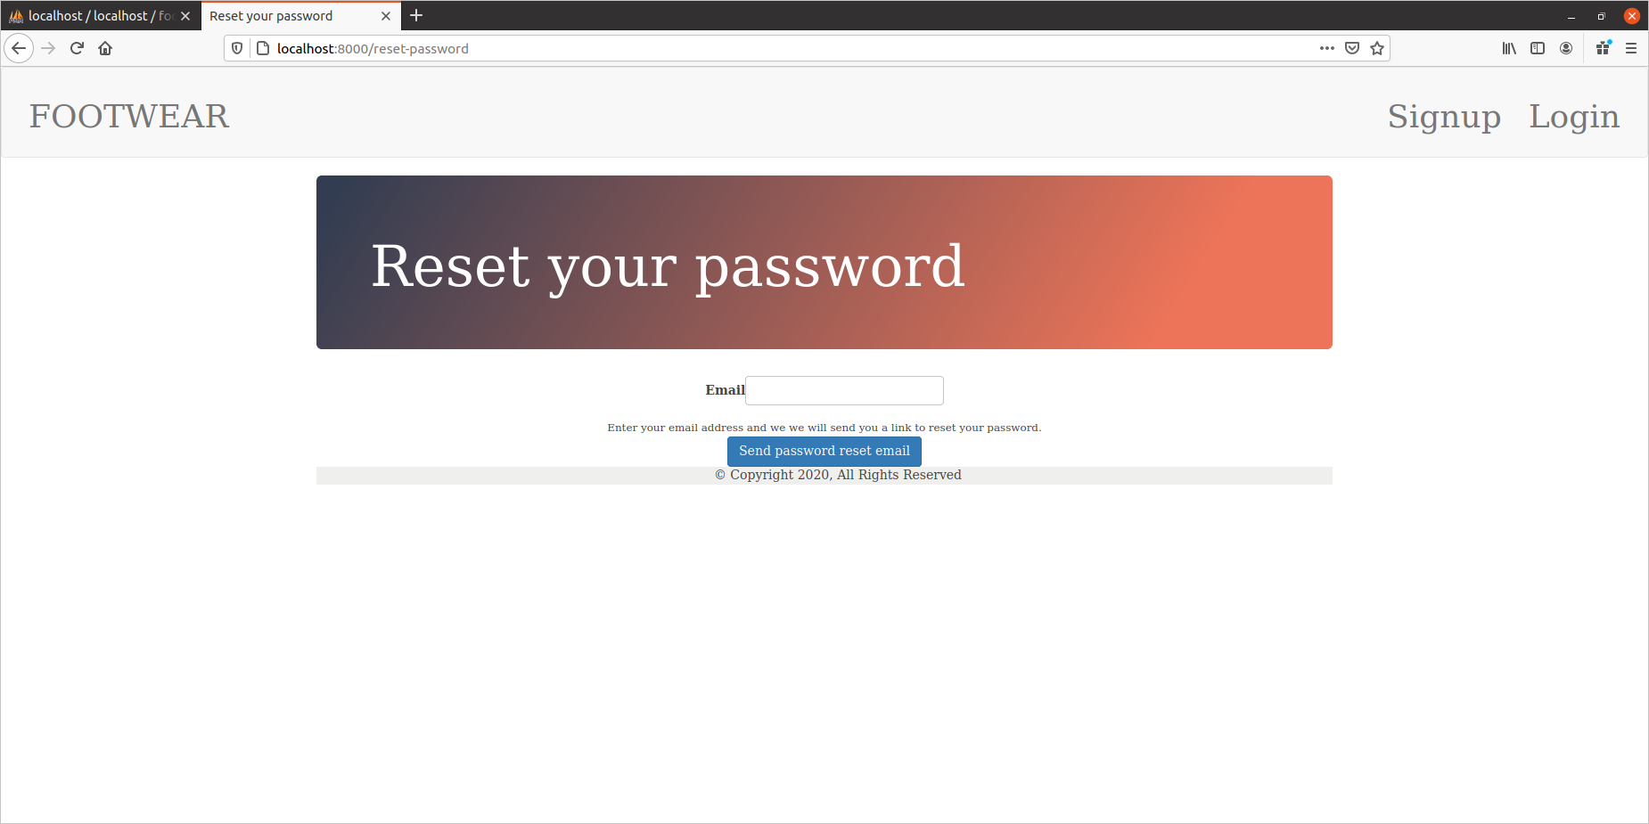
This is the reset password page user can reset the password by entering the same email id on which he is registered.

Now there are multiple roles in our website so there are multiple page for the roles so when the user will login to the website he will land to the a page according to his roles and will be able to perform actions according to the privileges of his respective roles

LOGGING IN AS A NORMAL USER

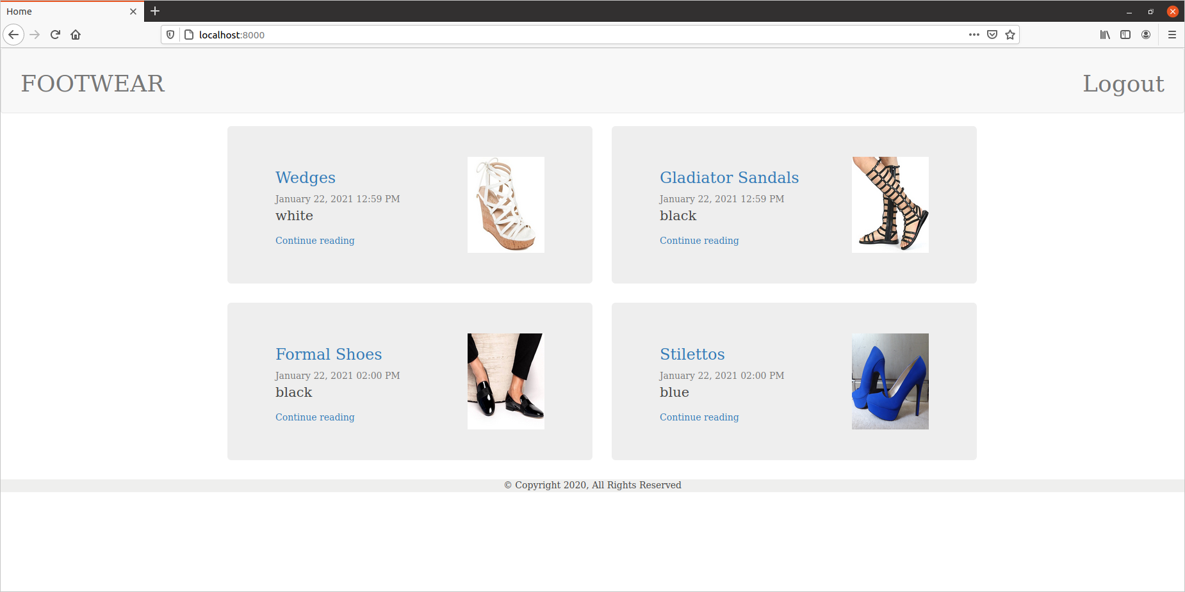
This is the page on which the normal user will be rendered when he will log in and he also has the option of the logout .(Thought process being that was that user can see the products without being logged in but to comment or review then the user mus register to on this existing page we can add the option to comment or review and for comment – WIP )

LOGGED IN AS ADMIN

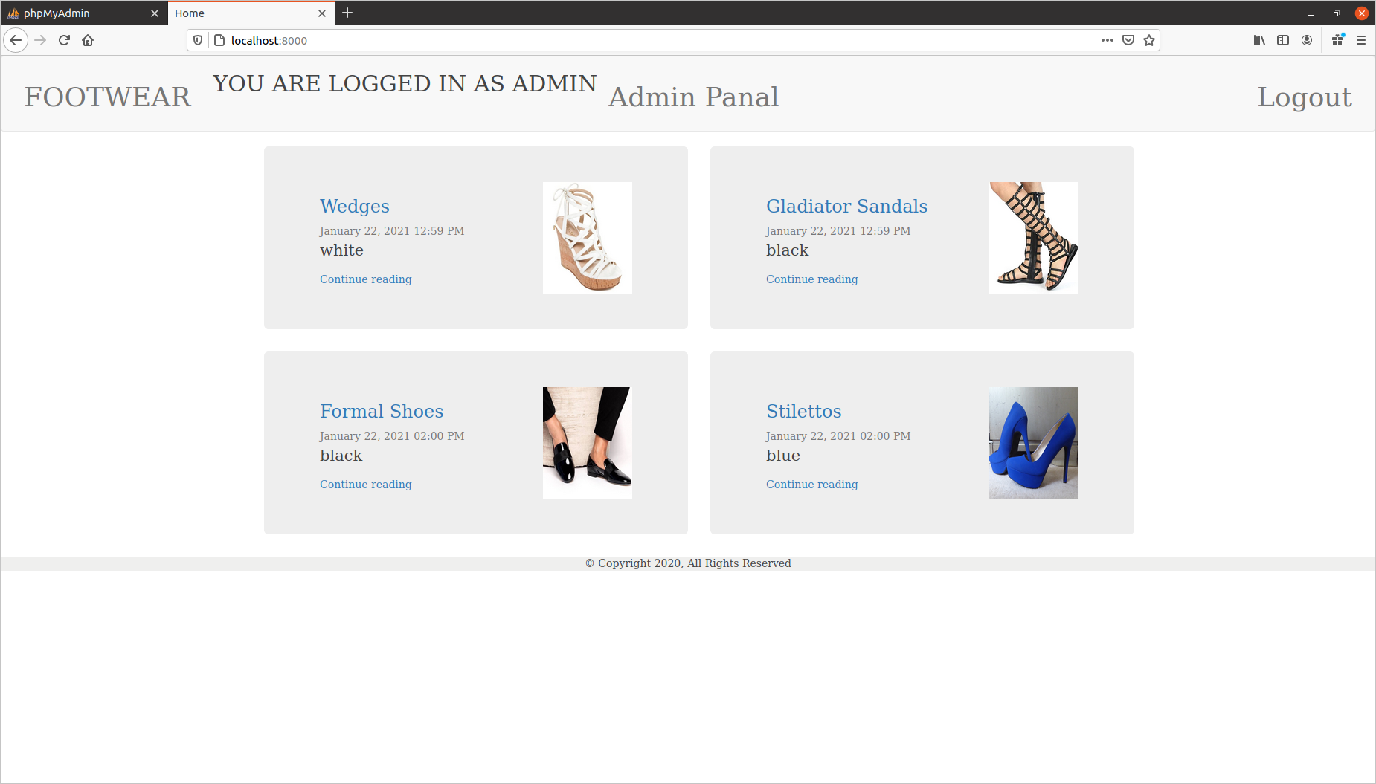
When the admin will be logged in then this will be the page on which he will be rendered and now admin will have an extra option to go to the admin dashboard so now when admin clicks on the admin panel then he will be rendered to the admin dashboard as shown

ADMIN DASHBOARD

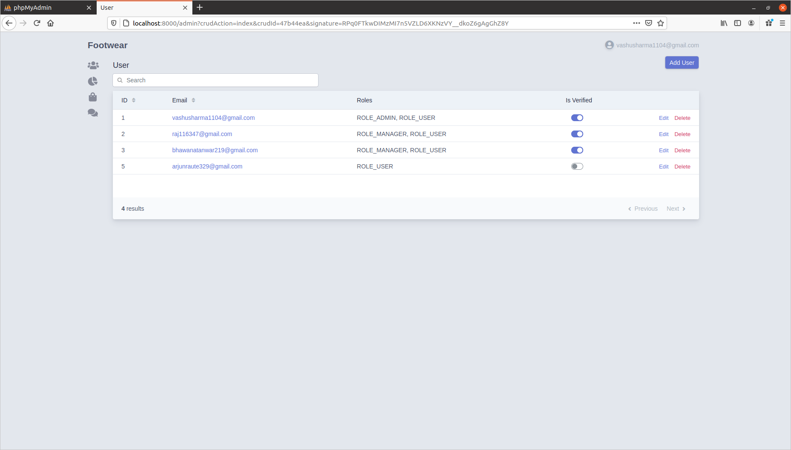

Here on this page the admin has access to ses the users information and he has all the privileges to add delete edit the role of the user any thing he has all the privileges

now if admin wants to see the category of the products he will select the category option from the dashboard then he will be rendered to the following page

CATEGORY DASHBOARD PAGE

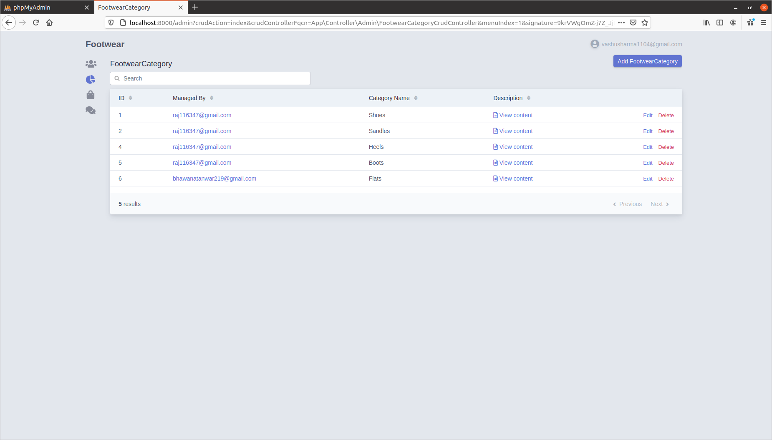

Now after landing on to this category dashboard page the admin can perform all the task that he wants to because he has all the privileges

If the admin wants to see the products information then he will click on the products options from the menu then he will be rendered to the products dashboard page as shown

PRODUCTS DASHBOARD PAGE

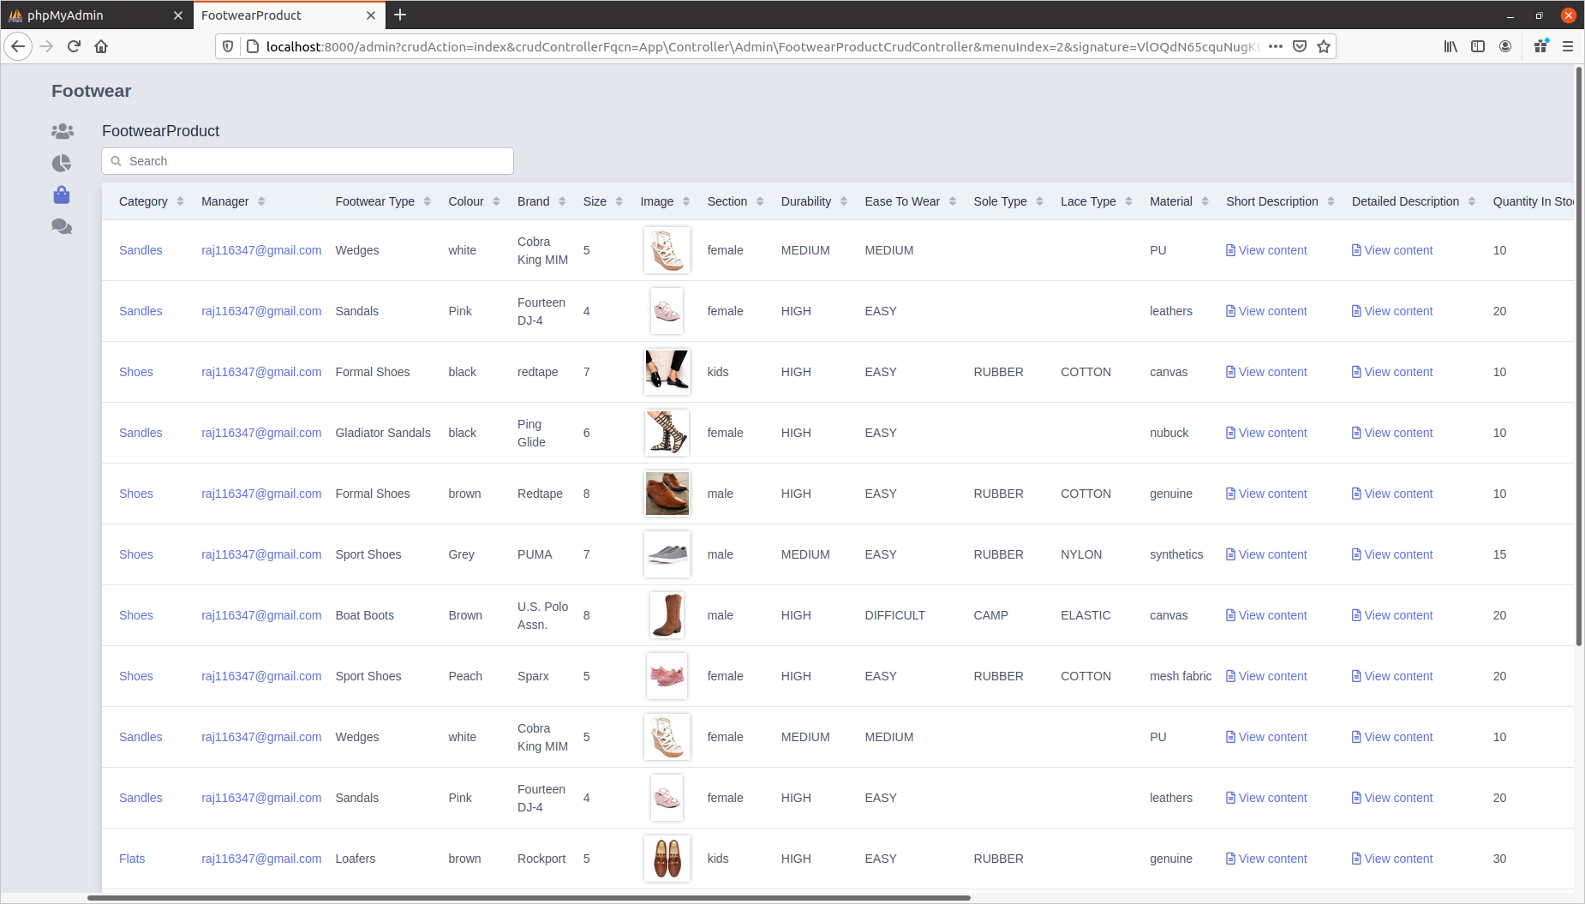
Now Admin can see all the information about the products and he can also perform all the required action he wants to perform on this page like adding,deleting,editing anything .

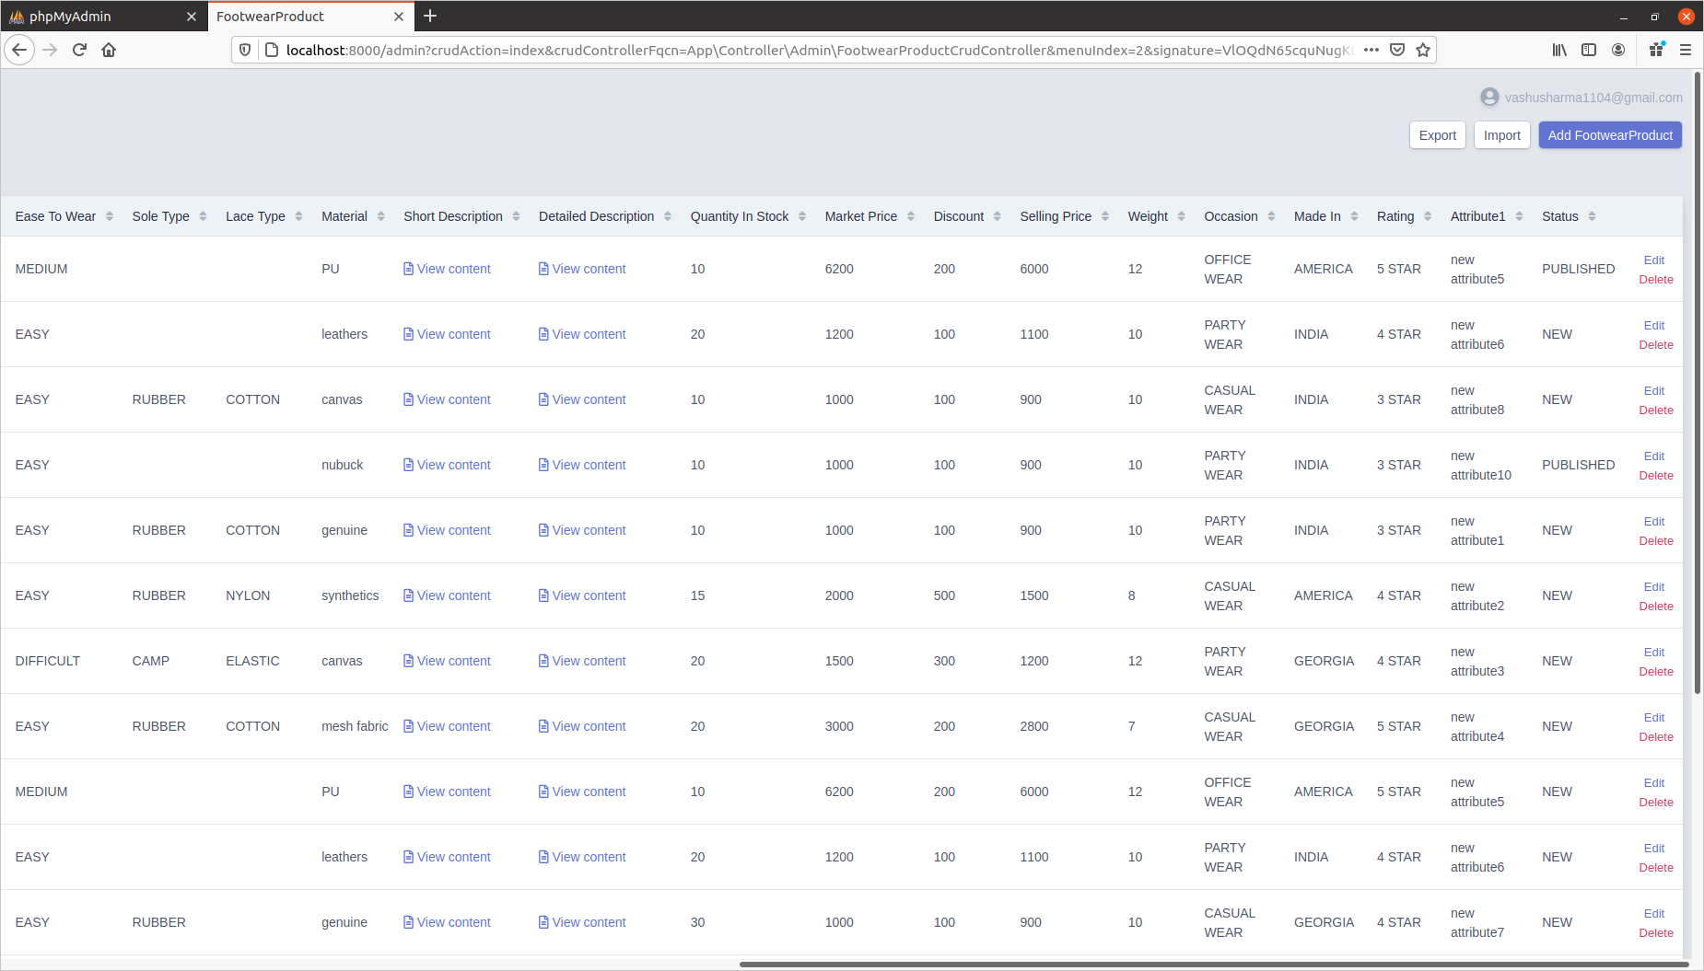

LOGGING IN AS A MANAGER ROLE

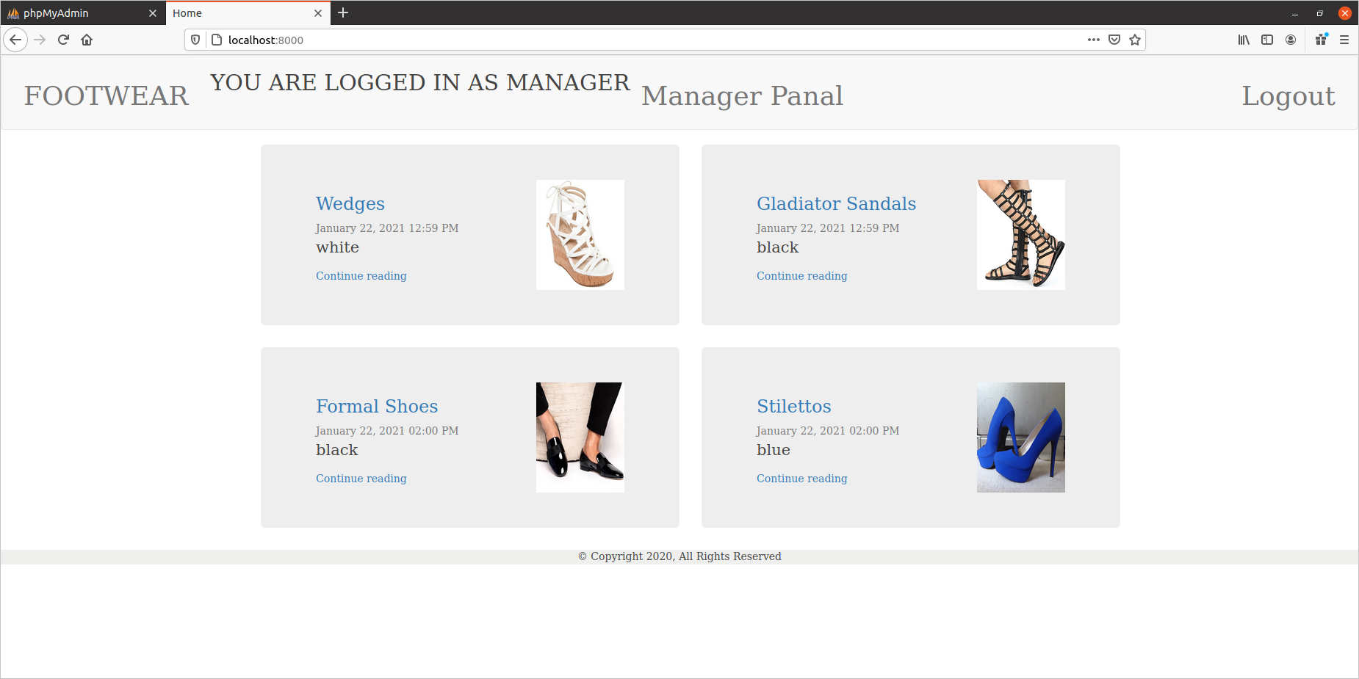
When a user with the role manager will login then this will be the page on which he will be rendered so mow manager has an extra option to go to the manager dashboard to perform the task/action he has been assgined so now when the manager clicks on to the manager dashboard link then he will be rendered to the following page

MANAGER DASHBOARD PAGE

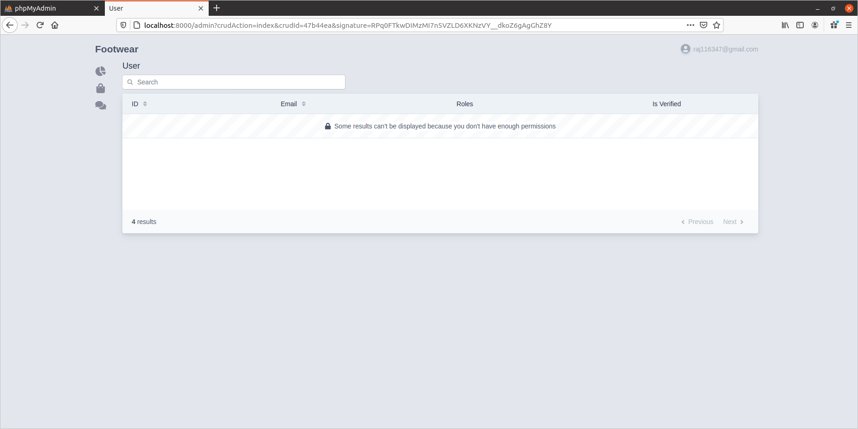
When manager will login to the dashboard then he will land to this page and as we can see even if the admin or any user has the access to the url of any page then also he will not be able to see the information.
Information can only be seen , action can only be performed according to the ROLES.

Now here in our case manager can have access to only see the categories but he cannot add,del,edit them so when the manager clicks on the categories option then he will be able to see the dashboard as

CATEGORY DASHBOARD PAGE

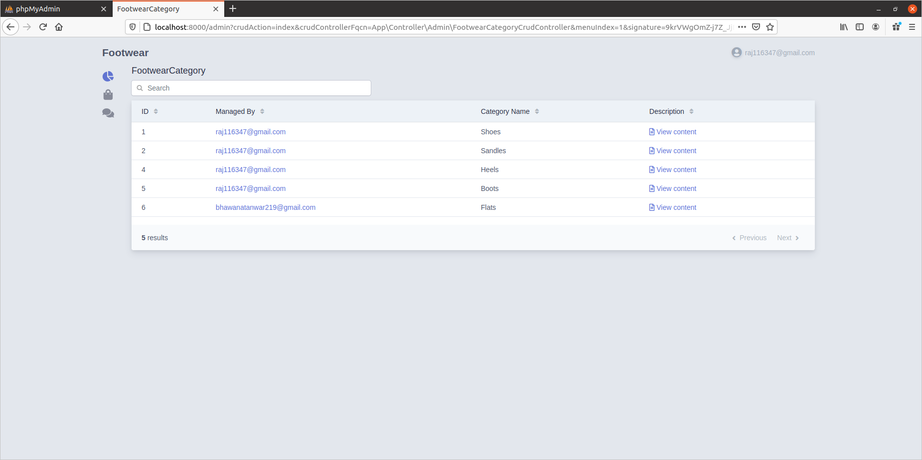
Now here we can see that admin can see the information of the categories but cannot delete,edit, or add any categories because he does not have enough permission.

In our use case the MANAGER ROLE can manage all the products so he has all the privileges to perform all sort of actions on to the product dashboard page so for manager the products dashboard page would look like as shown

PRODUCTS DASHBOARD PAGE

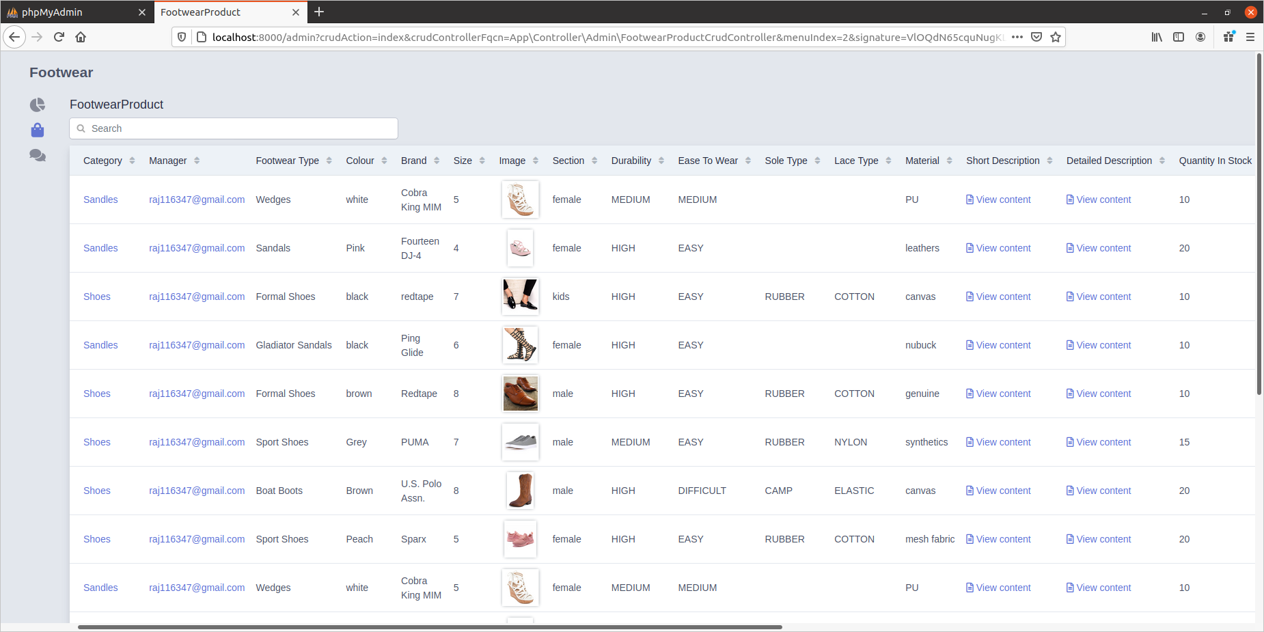
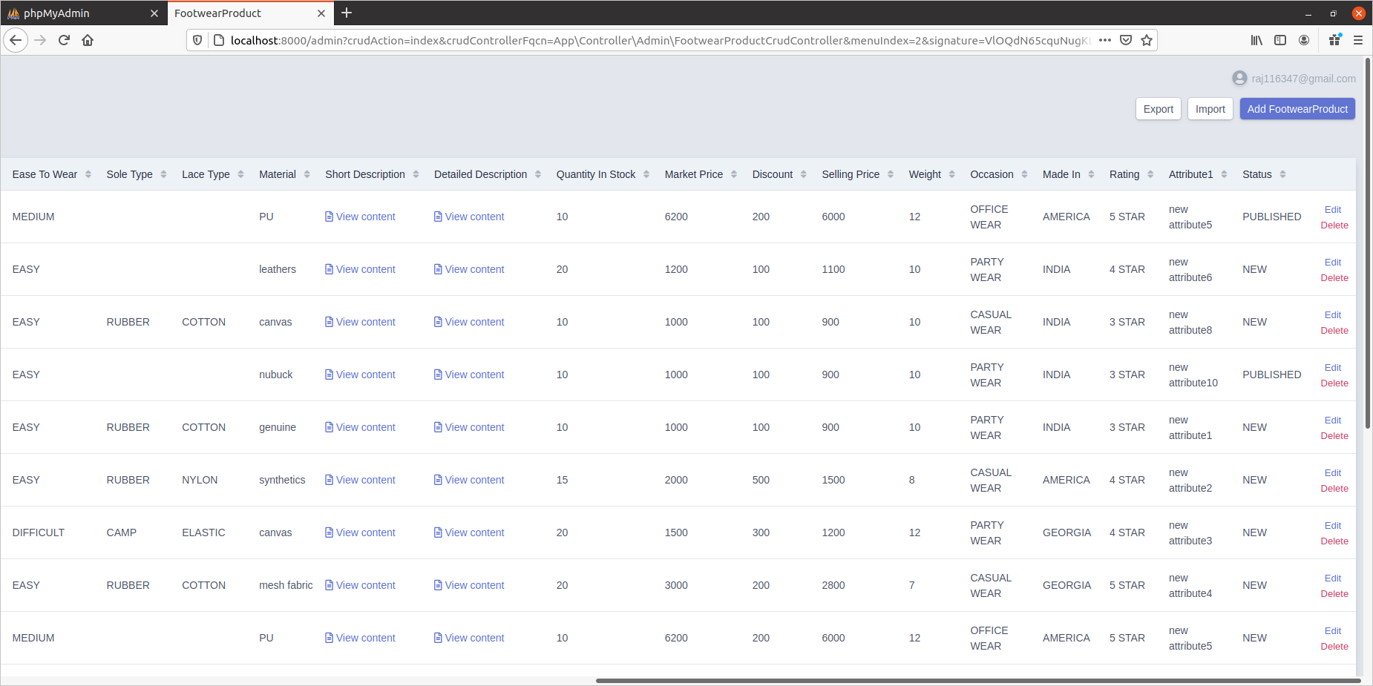

Now here we can see that as the ROLE_MANAGER has the access to manage the products so he has all the options to perform all sort of actions on this page he can import,export,add,delete,edit all the products.

This is the concluded user interface of our web application

1. The default page

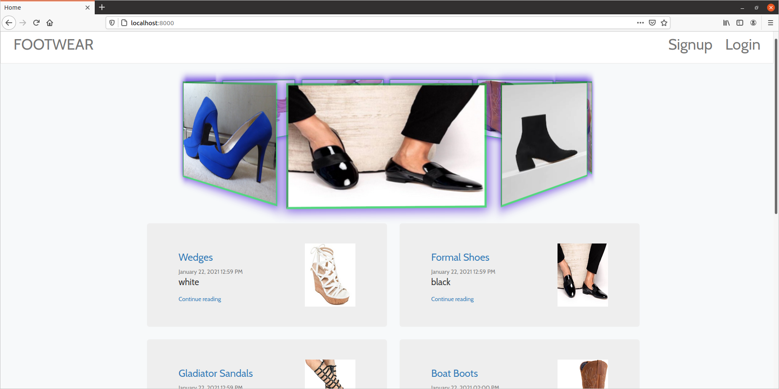

2. Sign up page

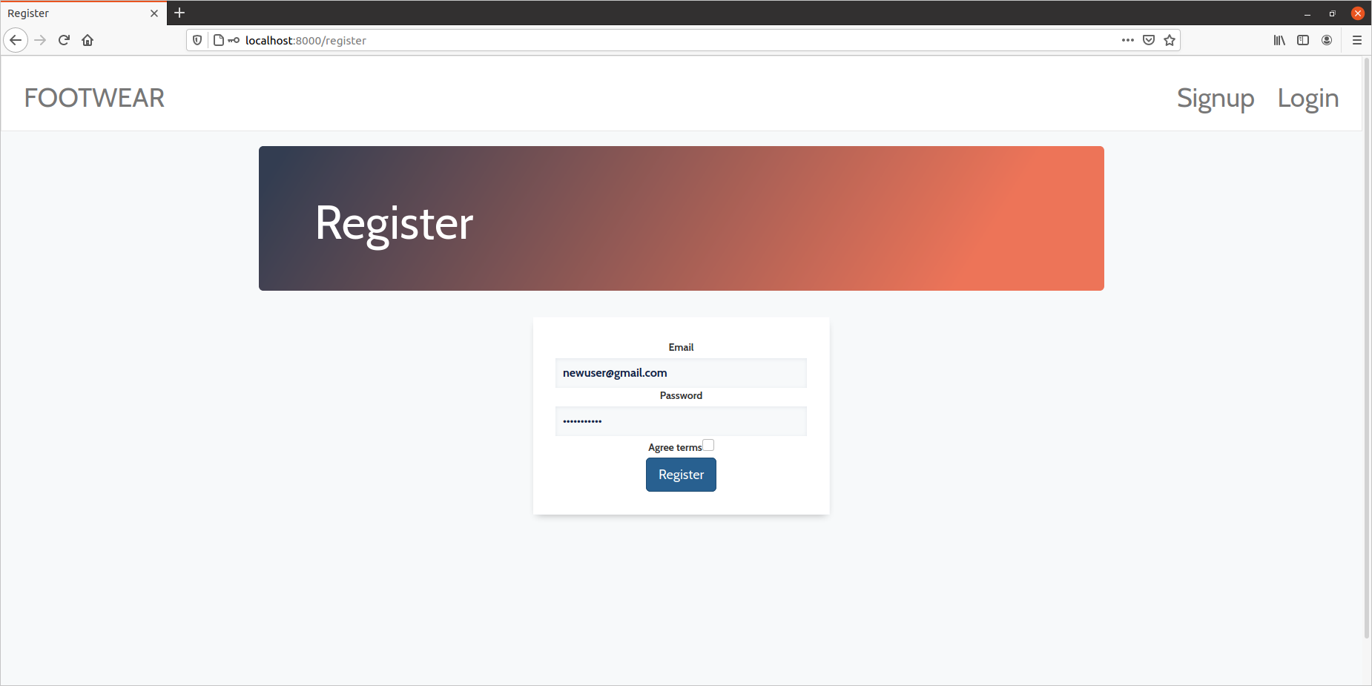
New user will register by entering his email and password and then he will be redirected to login page

3.Login Page

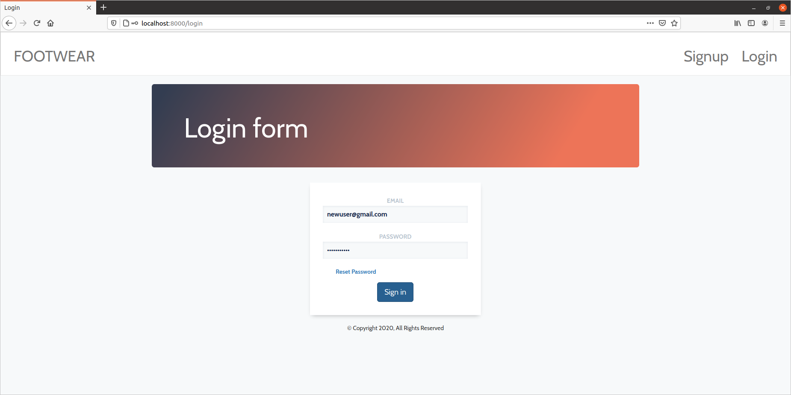
Now user will use his email and password to login into the website , and there is also an option for the user to reset his/her password now when the user clicks on the reset-password then he will be redirect to the reset-password page

4. Reset-password

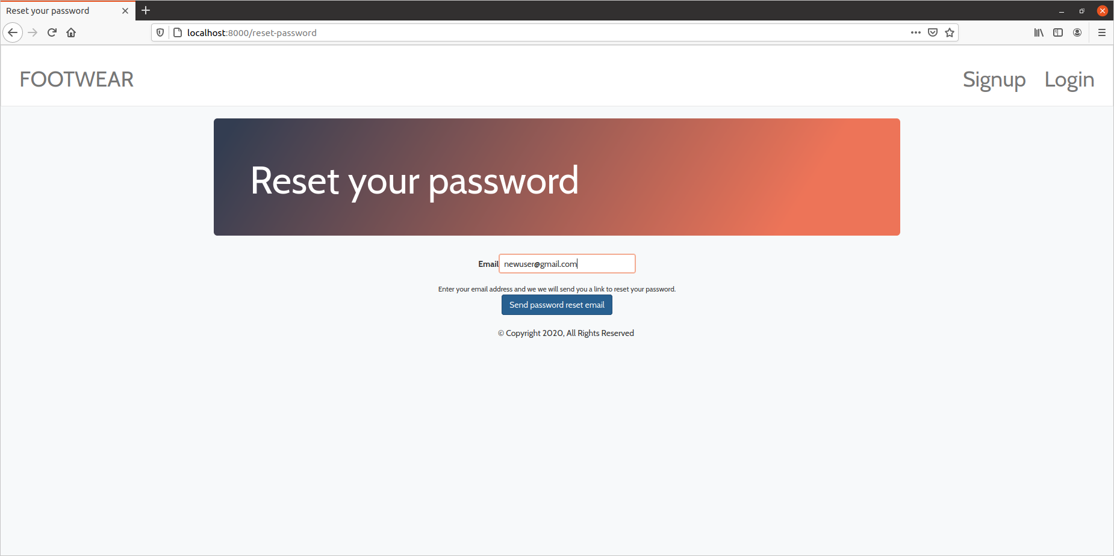
Now user will enter his email to send the reset password mail.

Now in the mail you will get a link so now just click on that link then a page will appear to reset your password as shown below

5. Reset-password page

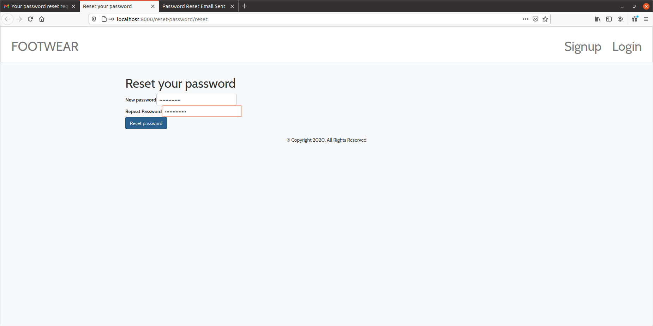
Now you will enter the new password and confirm it then again go back to login page to login using your new password.

Now when a normal user will login then that page will look like this

6. Normal User after login

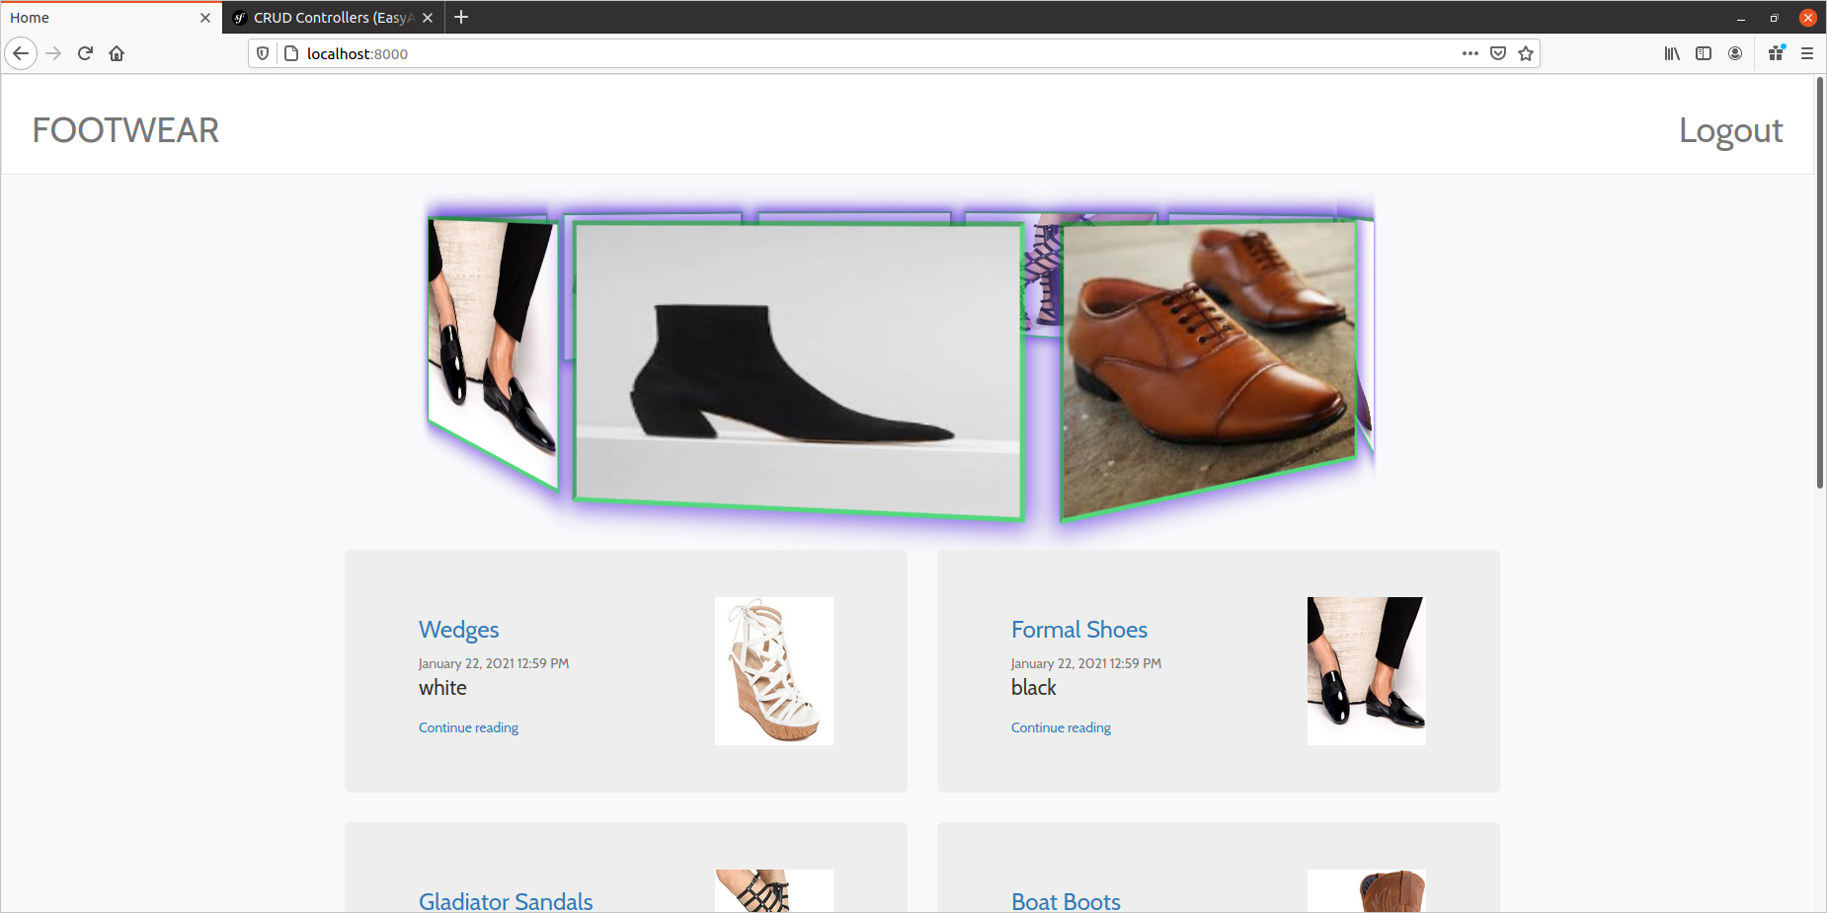
So here user can only see the products and does not have any option to go to the admin panel or anything he does not have that privilege.

7. Admin After Login

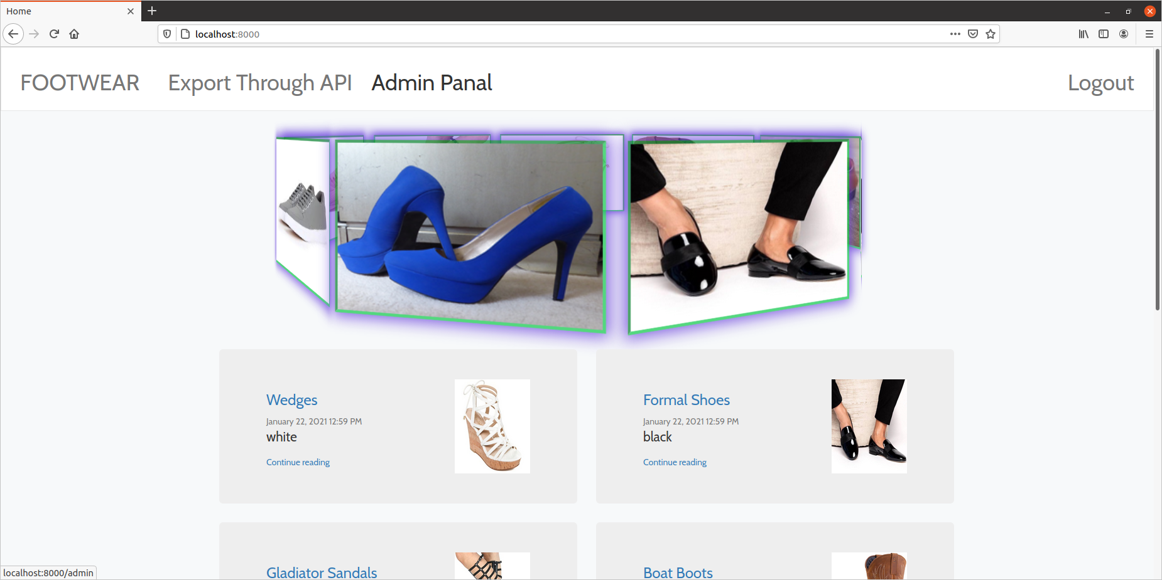

This is the Page that will be visible to Admin he has the option to go to the admin panel now when admin will click on the admin panel option then he will be redirected to the admin panel

Admin dashboard

8. Users information

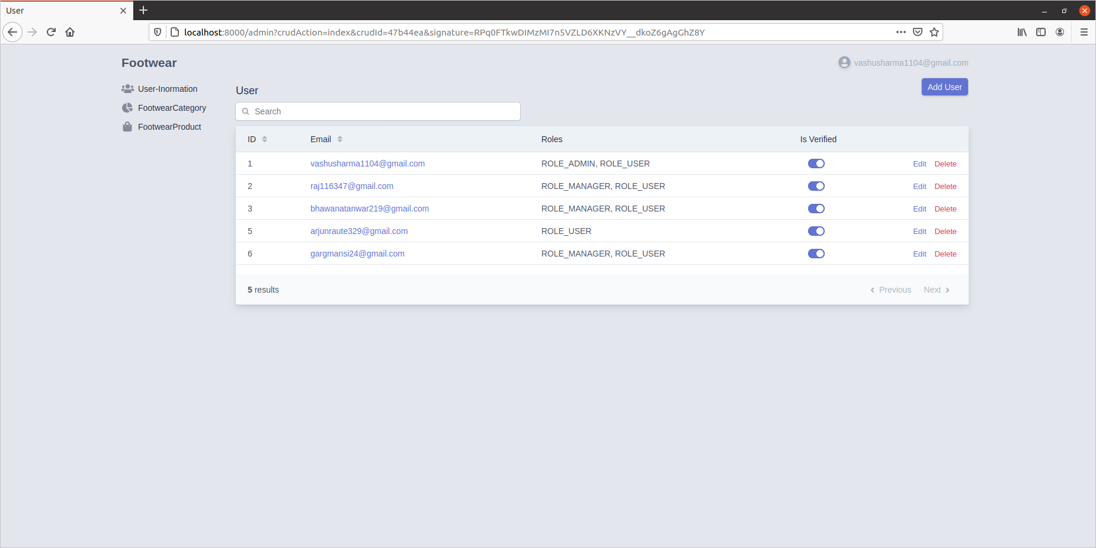
Admin will be able to see the users information and can perform all sorts of crud

He also has other options in the menu and if he clicks on the footwear categories then categories page will be rendered

9. Footwear Category page

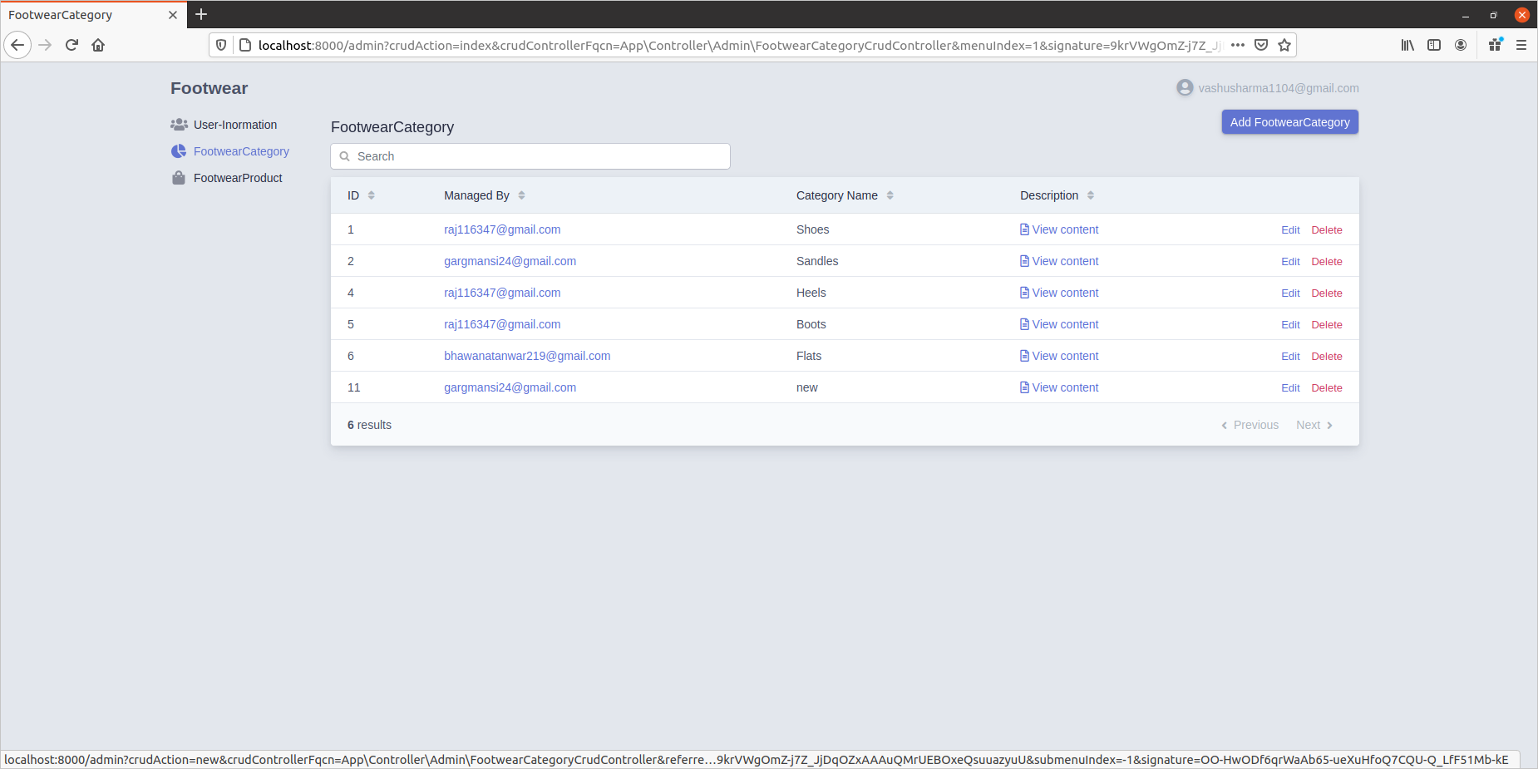
Admin can perform all sort of actions in the category page as you can see he has all the option to add ,delete edit the category

Now if admin clicks on the Footwear Product then he will be redirected to footwear product page

10.Footwear Product page
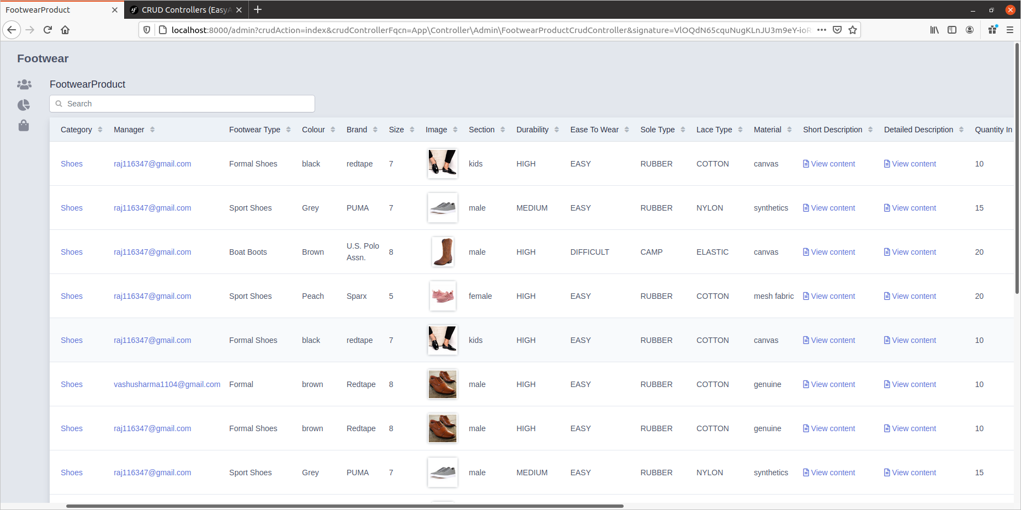

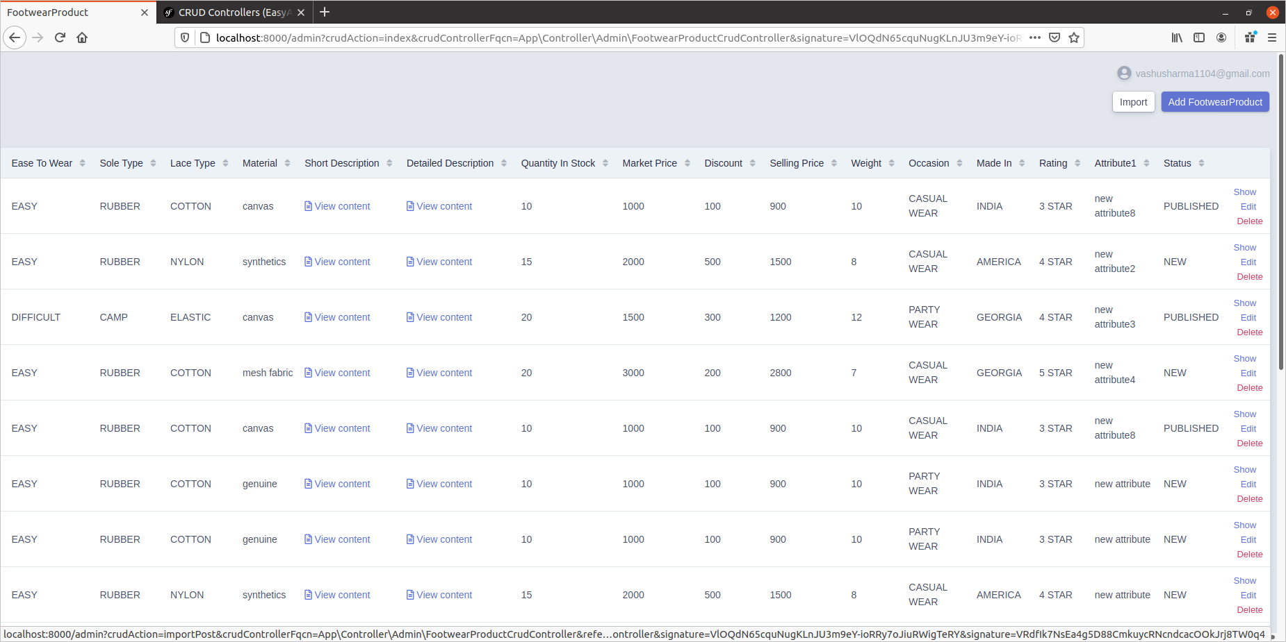

This page has all the product detail and similarly admin has all the option to perform all the action on products also you can see an import button on the page now we also have a function to import bulk data using JSON file so now to import bulk data into the product table admin will click on the import button .

11. Importing data
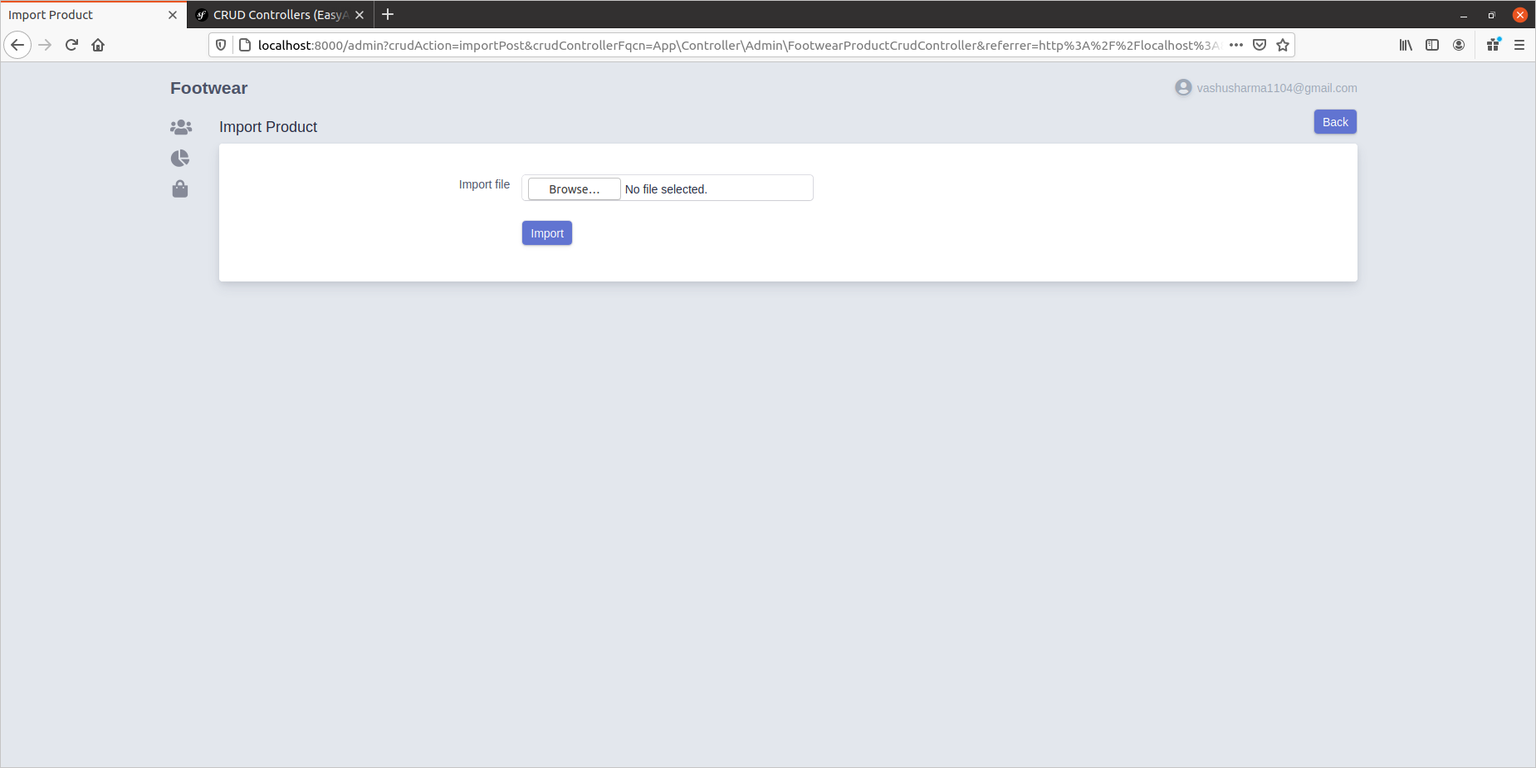

Now we will select the JSON file from the system
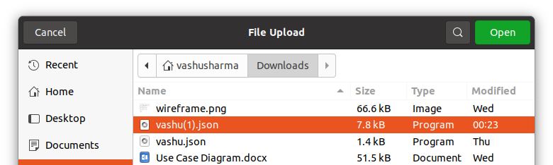

and then data will be imported into the system

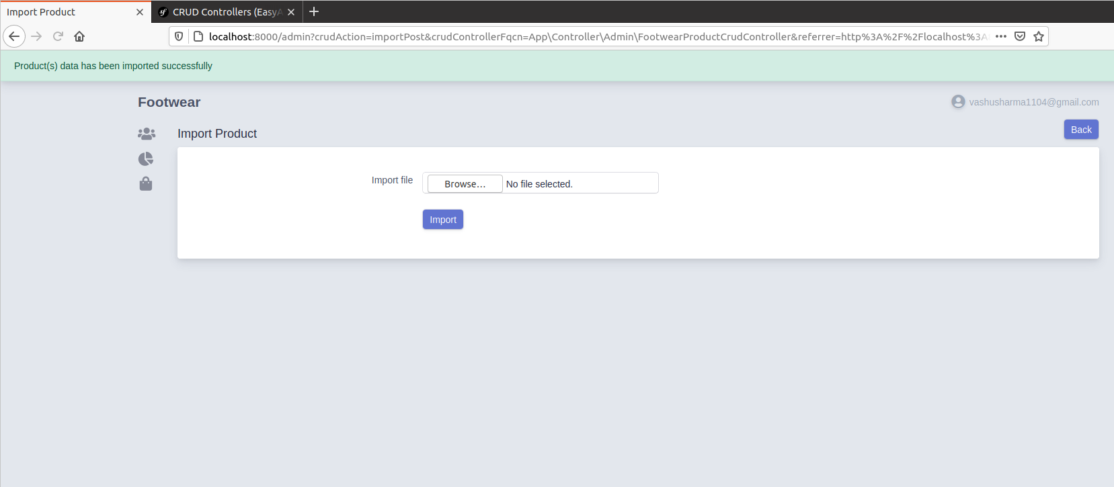

12. Exporting data

Admin also has the option to export the data from the product table by the option provided as Export through api and we have also added a function that only published data would get exported.

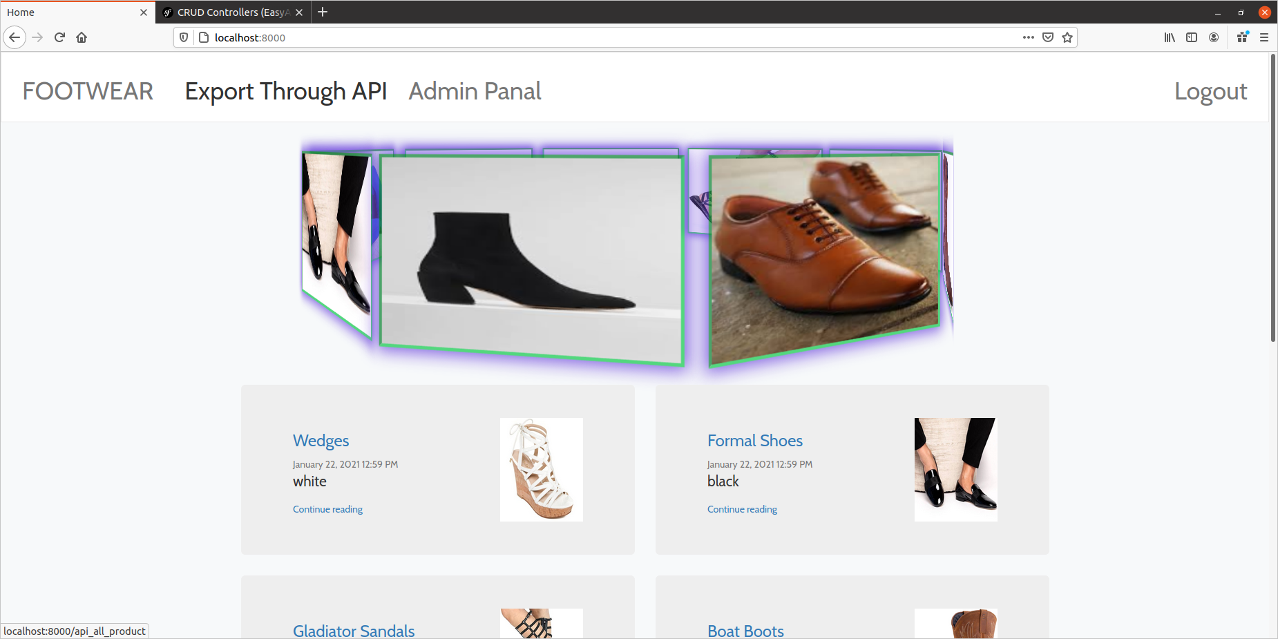
Now admin will be directed to the link where all the data will be present into the JSON form.
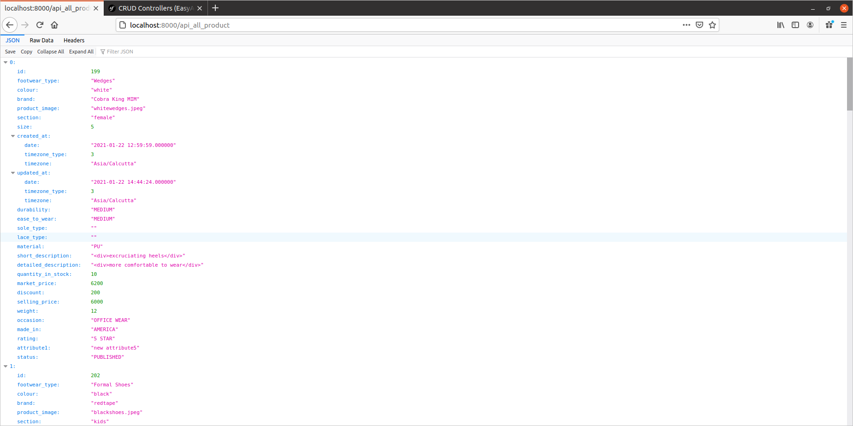

→ Raw data form
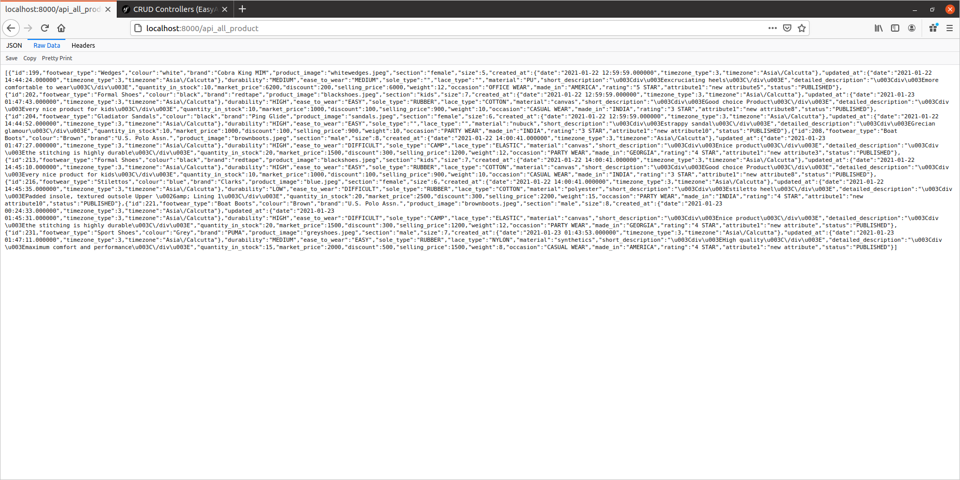

Exporting:
We have created an API crud controller which is returning the products data in the JSON form and we have also placed a toArray function in the footwear products entity which is returning the data in the array form and we can see that data in both raw data and the json form on the link provided

Now the Manager user will login to the website and he will see the home page as shown below :

13. Manager Home page

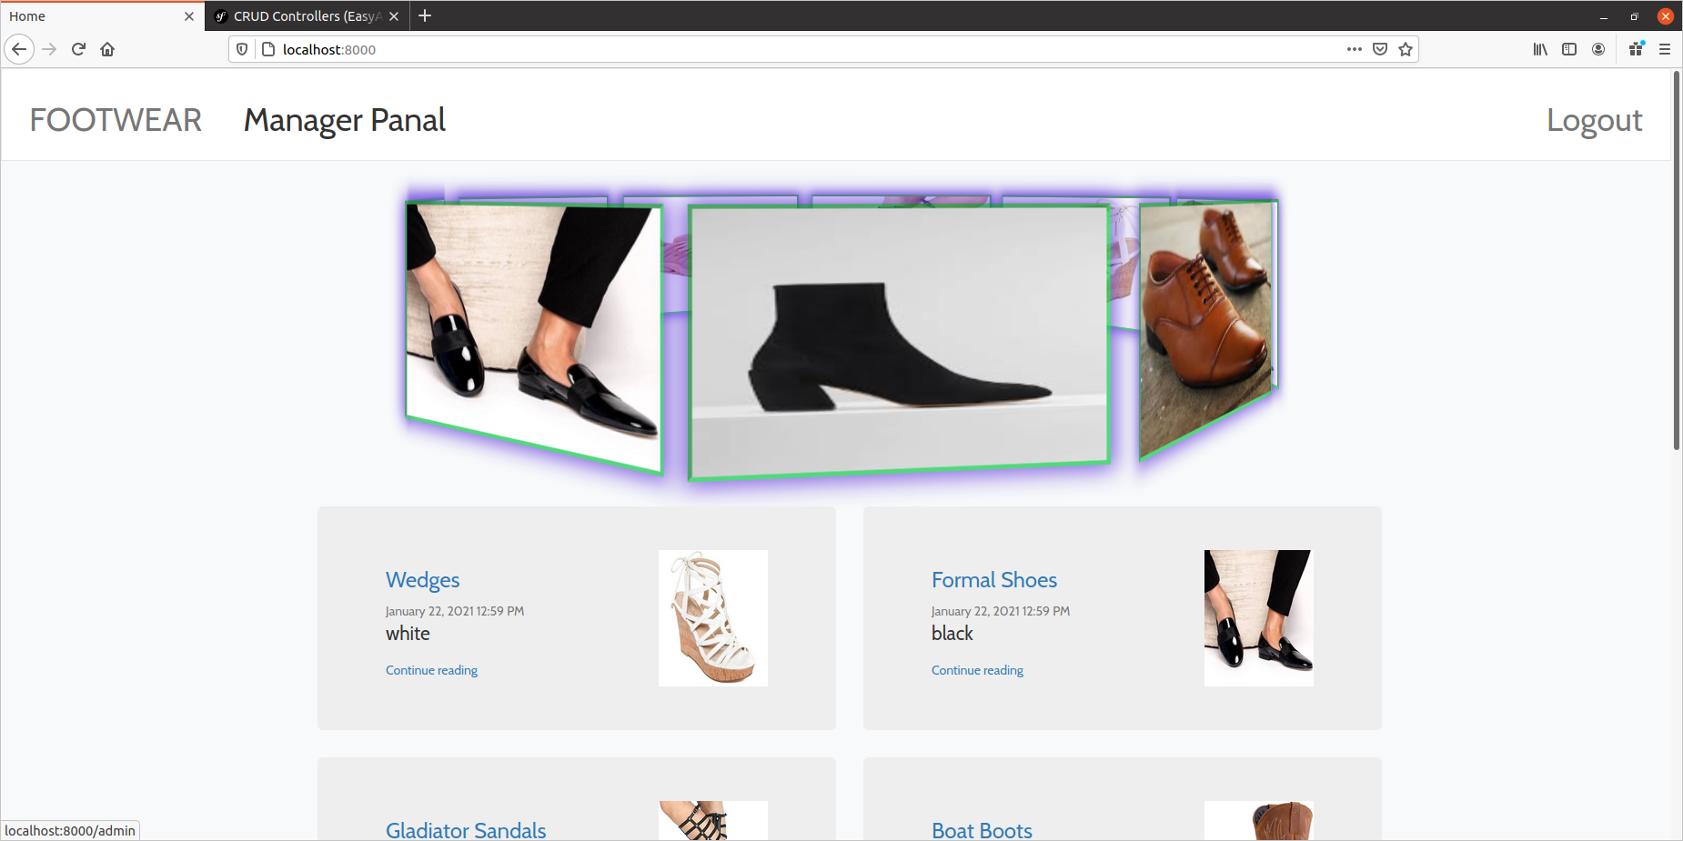
This is the manager home page and manager has the option to go to the Manager Panel to perform all sort of actions that has assigned to him the manager panel will look like this

Manager Panel

14. User’s Information

Manager will not be allowed to see the users information even if he access the user’s page through the URL
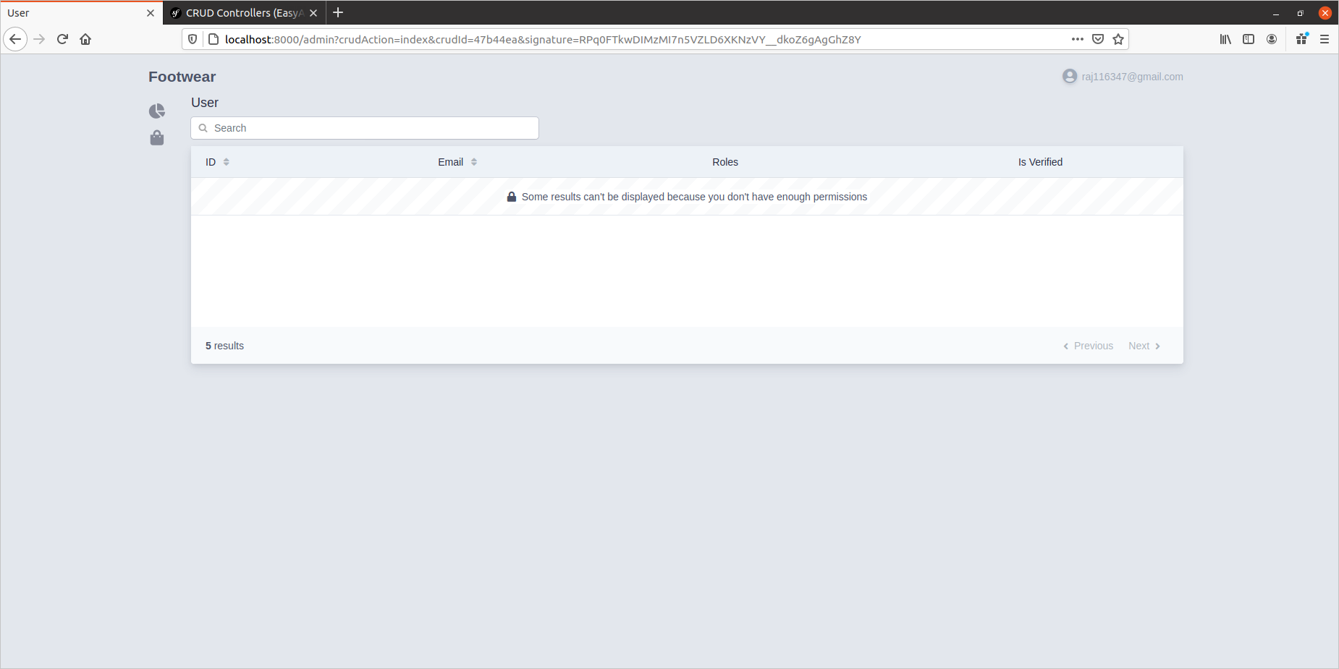
(ONLY ADMIN CAN SEE THE OTHER USER’S INFORMATION)

Manager role has the option to go to the category page to see what are the available categories and to whom they are assigned to it would look something like this

15. Category Page

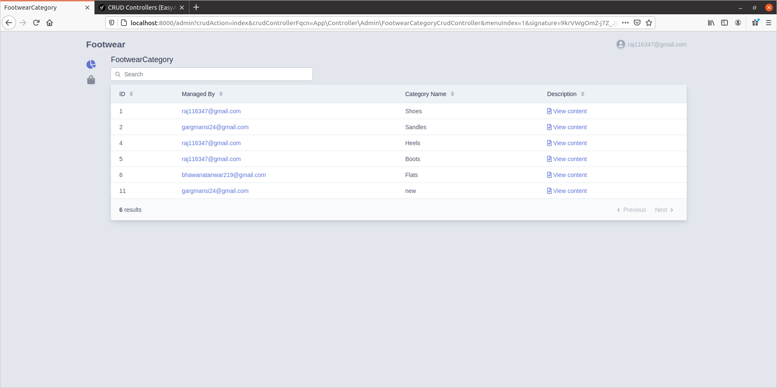
Manager has the access to see the category page but he has no permission to perform any sort of action on that page so we can see that there are no such options as add,delete,edit etc.

In our use case the Manager is allowed to perform all sort of actions on the product page so when he will click on the products option then he will be redirected to the Product page

16.Product page

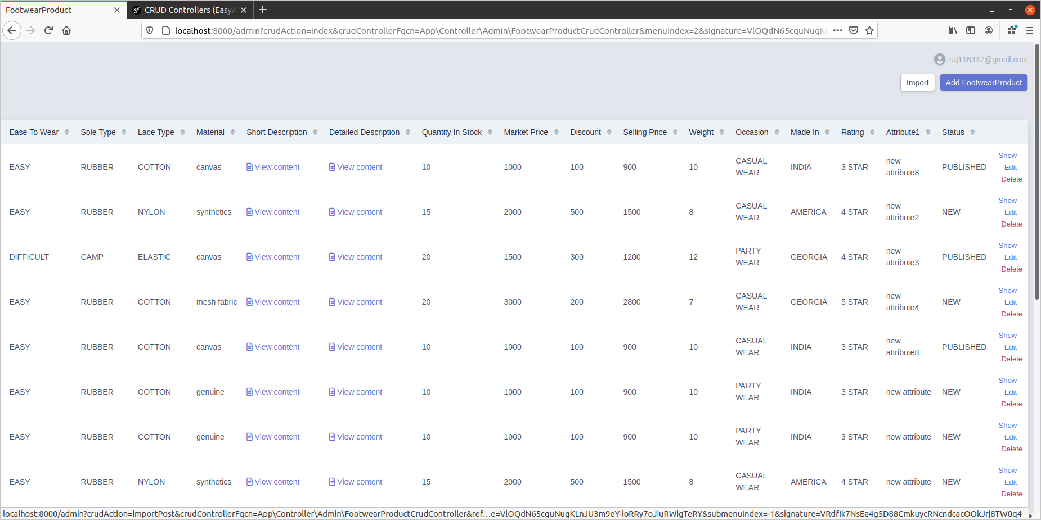
Here we can see that on the product page manager has all the information of the product and he has all the access to perform any sort of task on this product page like edit, delete, add , import .

Also there is a status field in the products , so we have used enum for that so whenever a new product is added then its status field is pre-persisted as New and then the manager has the privilege to check the product and if he has some doubt regarding the product then he can change the status to review and if he has checked the product is good and valid then he will change the status to published and then that product will be displayed on the home page for all the users As shown below.

Here on this home page users can only see the published products



